**ISEP: Innovative School E- Learning Platform with SMS Technology**

**A Capstone Project**

**Presented to**

**The Faculty of Information Technology Program**

**St. Bridget College**

**Batangas City**

**In Partial Fulfillment**

**of the Requirements for the Degree**

**Bachelor of Science in Information Technology**

**By**

**Baes, Nicole M.**

**Banaag, Lilibeth S.**

**Bautista, Ronnel D. Jr.**

**De villa, Leonard M.**

**Manalo, Giselle P.**

**Macatangay, Jericho C.**

**April 2022**

# **CHAPTER I**

# **THE PROBLEM AND ITS BACKGROUND**

## **Introduction**

In a Capstone Project, entitled ISEP: Innovative School E-Learning Platform, the main objective is to build a learning management system solution that provides the flexibility and accessibility that the users need to ensure normalcy in their day-to-day routine.

Learning Management System (LMS) is a software application or Web-based technology used to plan, implement, and assess a specific learning process. Typically, a learning management system provides an instructor with a way to create and deliver content, monitor student participation, and assess student performance, (Rouse, 2013).

These days, the significance of an E-learning system is extremely high, and there are several factors why it is important. The pandemic crisis has brought a big percentage of the world’s educational institutions to stop operating in the hopes of minimizing harm to their students.

Nowadays E-LMS provides continuity in education. It ensures the health and safety of many young students. Health and safety are necessary and are the top priority of every organization and the government these days.

Thus, the educational institution is not too far behind this trend. Hence, more institutions are looking for the best virtual classroom, where they can continue operations while also ensuring everyone’s health and safety.

One concern with online learning is how one can guarantee its effectiveness. Learning from home is a whole unique experience compared to learning inside a classroom or a conducive learning space. Students and teachers can easily be distracted and unable to focus when they are in the comforts of their homes.

This capstone project collates all the academic-based tasks into one portal that allows interaction between students and teachers in synchronous and asynchronous mode.

The target clients of this project are those academic institutions that want to improve the quality and accessibility of their online learning system. Initially, the developer’s work focused on a selected pilot school which is St. Bridget College.

Resources from electronic media, assessment of student performance through online examinations, monitoring of student participation through score monitoring and interest to subject matter even advanced communication medium between teacher and student through posts, and for some advanced e-learning systems are all packaged into this innovative system that supports educational processes through the use of information and communications technology.

Developers designed this ISEP since we are dealing with a pandemic and want to create an online learning management system. There are several LMS that are currently providing all the necessary support to students and professors. However, they provide all the tools or features that the users require, but not all the features are accessible, thus they are not used by most of the users. Additionally, on the part of the student when they missed to complete the task, assignment, or even quizzes given by the teacher. One concern with online learning is how one can guarantee its effectiveness. ​

Parallel to this situation is the development of ISEP with SMS technology. It is a program that will update the user for due date/missed of the learning assessment through SMS. Users do not need internet connection to be updated for the given assessment. The system will improve the learning process offered in the institution to promote the efficiency of e-learning in teaching, acquiring knowledge within the target subject mastery and solve educational problems presently encountered by the student. Additionally, this system supports synchronous and asynchronous modes of learning.

## **Project Context**

As we face this time of the pandemic, all sectors of society rely on technology to cope with difficulties. People quickly adjust to this new normal. Different institutions think about how they face this challenge. For education, an electronic learning management system is the answer to this new normal. LMS helps monitor students’ progress and performance in the course. It has an in-built feature that keeps track of their records, grades, submissions, and engagement with the course. Likewise, it collates important files and documents shared by the students on the platform. The system, entitled ISEP: Innovative School E-Learning Platform with SMS Technology provides an interactive and user-friendly learning management system. It will be easier for the student, teacher/professor to interact regarding academics.

The project intends to help students and professors to provide tools and features to help mimic experiences and activities that usually happen within a traditional classroom. Teachers can post and upload PowerPoint presentations on the platform. They can distribute supplementary learning materials to their students in the course, post reminders, hand out assignments, and administer tests. The notification system is essential because it helps the institutions to deliver information, activity, or event announcements to the targeted recipients using SMS technology since the notifications they got are accurate. To deliver a lesson in our system you can have video meetings and share your screen to make communication with students and teacher easier.

## **Purpose and Description**

The system, entitled, ISEP: Innovative School E- Learning Platformwill provide an interactive and user-friendly learning management system, it will be easier for the student, teacher/professor to interact regarding academic. Teachers can continue with their job of instructing the younger generation, because it supported by internet communications media such as videoconferencing and chat. Eventually, in these tough times, LMS can provide a feeling of normalcy.

This capstone project also focuses on repository of learning materials relevant to the course. It makes them all easily accessible, copied, and downloaded by anyone enrolled in the course. The results of the study will be of great benefit to the following:

**The students.** The main concern of this project is the student who will view, send their activities, or even access or download file, and stay connected with their schoolmates and professors. Since online learning provides flexibility in terms of where, how, and when they can be accessed, students can learn anytime and anywhere they want. Students will be updated with the events through SMS technology.

**The Teachers.** This study will provide absolute control over how they want to teach and interact with their students. They have various tools to choose from to support their preferred teaching styles. Likewise, they can upload files, PowerPoint presentations, modules, and others to supplement their syllabus.

**Objectives**

The study aimed to develop a web-based learning management system solution that provides flexibility and accessibility where users will be ensured stability in their day-to-day routine. The project is intended to improve the current Learning Management System. The system will be developed through the use of various web technology such as HTML, CSS, JavaScript as its front end and PHP as its back end. The study specifically sought to:

1. design a system that will provide a better way of studying online and makes it easier for the student to use the system for their study in terms of:
   1. a user-friendly web-based learning system with an SMS function by giving appropriate and quick access to its features.
   2. providing a responsive web-based learning system to be accessed by different devices.
2. develop a system that will satisfy the needs of the users for their learning/study that will be capable of:
3. providing the needs of the student for online schooling.
4. for allowing communication between teacher and student in synchronous and asynchronous learning mode.
5. sending and viewing student learning activities
6. reminding student of their due and missed date assessment through SMS technology.
7. evaluate the developed e-learning management system called “ISEP” that complies with the ISO 9126 standard for software development.
8. prepare an implementation plan for the deployment the “ISEP.”

## **Scope and Limitation**

The goal of our project is to make it easier for students and teachers to communicate by utilizing our LMS. The great thing about this project is that users can still receive announcements even without internet access. This platform supports both synchronous and asynchronous modes of learning. The project does not have the capability to open as an application of smartphone because it can only be opened in a web interface or in web browser. Initially, the developer’s work focused on the selected pilot school which is St. Bridget College.

The study is limited in that there are some situations in which the application might not update instantly because of potential changes in the weather, such as signal loss. When there is no Internet connection, the platform cannot be updated immediately with real-time information, but SMS can be used to get announcements about the student's assessment. Therefore, real-time access to the program requires an Internet connection. Additionally, this learning management system allows only up to 200MB file size when uploading a file. The file format when uploading file is limited only to document, presentation, spreadsheet, PDF, and image except video.

## **Definition of Terms**

To provide a clear medium of communication between the proponents and the readers, the following terms are defined conceptually and operationally:

**Administrator** - a person whose job is to manage a company, school, or other organization.

**Course** - A series of lectures or lesson in a particular subject, qualification or program of education leading to a degree or diploma.

**Database** - Conceptually, the terms refer to a collection of pieces of information that is organized and used on a computer (Merriam-webster,n.d.). As used in this study, this term refers to the centralized storage of students and teachers with information that can be used in the system.

**Download -** In computer networks, download means to receive data from a remote system, typically a server such as a web server, an FTP server, an email server, or other similar system. This contrasts with uploading, where data is sent to a remote server.

**E- learning System -** A learning system based on formalized teaching but with the help of electronic resources is known as E-learning. While teaching can be based in or out of the classrooms, the use of computers and the Internet forms the major component of E-learning.

**Feature** - A notable property of a device or software application.

**Forum Site -** An Internet forum, or message board, is an online discussion site where people can hold conversations in the form of posted messages. They differ from chat rooms in that messages are often longer than one line of text and are at least temporarily archived.

**Learning Management System -** A learning management system (LMS) is an online education hub that provides a large and indispensable set of features to support educational activities such as classroom learning, distance education and continuing education.

**System** - A system is a collection of elements or components that are organized for a common purpose. The word sometimes describes the organization or plan itself (and is similar in meaning to method, as in "I have my own little system") and sometimes describes the parts in the system (as in "computer system").

**User-Friendly-** Easy to use or Easy to understand.

**Web-based applications** - are a particular type of software that allows users to interact with a remote server through a web browser interface.

**Web Interface -** A Web user interface or Web app allows the user to interact with content or software running on a remote server through a Web browser. The content or Web page is downloaded from the Web server and the user can interact with this content in a Web browser, which acts as a client.

# **CHAPTER** **ll**

# **TECHNICAL BACKGROUND**

The College Department of St. Bridget College provides a variety of events, programs, and schedules that are conducted as part of the school's curriculum. In addition, since the start of the pandemic, social media platforms have been used to announce details, events, and schedules.

Significant challenges with scheduling, activities, and events in the current operating environment have been experienced. Because of the COVID-19, online-class operations became the new normal, which presented several issues. Setting up the appropriate platform for scheduling in terms of time, date, and meeting has been a challenge. This has also misled some students and faculty members, who are not used to using the technology. Furthermore, students have a tendency to forget to complete or respond to the assigned learning assessments.

Considering these problems, the proponents proposed a system that would ease the process of distributing information. Alongside with this, the system intends to deliver information, activity, and event announcements to the targeted recipients using SMS technology that would palpably help the academic institution. The E- Learning Platform will be implemented at St. Bridget College as its pilot school for testing.

**Figure 2. 1**

## **Organizational Chart**

The figure shows the flow of passing and measuring information like events and announcements, and the posting of scheduled exams and activities in SBC. The scheduling of events is being arranged by the Student Affairs Office and the Administrative Team Committee members. The student’s has right to be informed of the announcements, activities, and further updates that will be held by the teacher.

**Figure 2.2**

## **Workflow Diagram**

The diagram shows how the system works. It shows the processes of the system. The Users will go to the website. The website can only be used if you have an internet connection. Upon login register an account and it will automatically save to the database. Then, you can now login to the website. If the system accepted your username and password, you may now go to the main home page. The Professors can now post documents, modules, and important updates or tasks that a student need. The students can already access the posts that the Professors posted, and they can be able to take exams and submit to the professors.

# **CHAPTER III**

# **REVIEW OF RELATED LITERATURE**

This chapter describes the concepts and principles used in the development of the study including other research literature, related concepts and synthesis of the studies cited.

## **Review of Related Foreign Literature**

According to Oliveira (2012), the E-Learning goal is to make the school more like closer to a classroom mode with relation to personal interaction and preserve the distance between teachers and students in order to improve the process of mediated communication, systematic guidance, and constant monitoring, focused on the formation of skills and attitudes that allow the student to have learning process autonomy in a continuous self-education. In this context, IT provides progressively greater flexibility and accessibility to education, culture, and professional and personal development, contributing to the creation of educational systems. The pedagogical potential of IT in the pedagogical mediation of e-learning has as main pillar the building of distance knowledge, thus modifying the paradigm that brings "knowledge as a state and not as a process" (Oliveira, 2012; Rosini, 2013). This literature states that in making e-learning management systems, developers should meet the needs of the user. It should be flexible and reliable for the students and teachers as they are in the classroom.

The proponents’ project is flexible and accessible because users can access ISEP using devices with browser and connected to the internet. The users can upload and download learning materials and activities, they are also updated on the events of the school through our SMS technology.

According to Abbad et. Al. (2009), system interactivity refers to students’ perceptions of the system’s ability to provide interactive communication between instructor and students and among students.

The interactivity between LMS users within the realm of its system enables learners to explore and play with the course materials and therefore becomes as a decisive element for improving students’ positive feelings such as perceived satisfaction and perceived usefulness.

A well-designed LMS that has an interactive bridge between and among instructors, the learners, and the instructional contents (learner-instructor, learner-learner, and learner-content) is believed to have a positive effect to its users and the possibility of online learning adoption.

They clearly stated that the system interactivity has something to do with the interaction and communication of the instructor and the students regarding with the instructional contents for a better and more effective way of learning, especially in distance learning.

The similarity of the proponents’ project is that the ISEP provides interactive communication. Student-users can communicate with his/her classmates or even with the teacher regarding academics. Teacher-users can communicate with his/her student or co-workers regarding his/her alternative work concern. In this way users can interact and communicate even at home. ISEP has video conferencing, where teachers can discuss their lesson. Video conferencing is used for synchronous learning to interact with the students.

According to Aleke & Akaniyere (2015), education (teaching and learning) is simplified using E-Learning resources. The use of ICT involves effective teaching and learning with the assistance of computers and other information technology acting as aids which perform complementary functions in the teaching and learning environment. The use of e-learning makes the teaching and learning environment possible and effective, especially in this time of pandemic. There are a lot of e-learning platforms that an institution can use, but they need to ensure efficiency of the platform they choose. Institution needs to ensure if the e-learning platform that they chose can support the needs of their students and teachers.

Recently, the teaching-learning process has rapidly assumed a new and drastic dimension, with multiple advanced technologies replacing traditional tools (Julian et al., 2019). Today, the existence of flexible, cost-effective, and efficient technologies enhances knowledge acquisition and transfer (Tschand et al., 2021). Currently, digital (e-learning) tools consistently eliminate numerous challenges hindering the transfer of ideas and intellectual collaborations across borders, such as long distances and the cost of transportation. E-learning platforms or Learning Management Systems (LMS) are internet-based learning systems rapidly adopted by educational institutions worldwide to completely revamp the learning experience for students and teachers (Aldosari & Mekheimer, 2013; Eldridge, 2014). E-learning technologies ensure seamless teaching and learning while virtually enhancing communication and exchanging learning resources (Poon, 2013). With the use of a learning management system, distance learning during the pandemic became possible. With video conferencing of the ISEP system, students and teachers who are using LMS can transfer intellectual ideas and can collaborate, and long-distance communication is no longer a hindrance. The project is particularly useful because the users can upload, download, and can communicate with each other.

E-learning management system allows students to take courses and attend classes and enable instructors to deliver lessons effectively and access students even from home. E-learning is one way to integrate student learning needs with technology (De Clunie et al., 2013). Learning management system must provide reliable documentation, administration, tracking, reporting and automation (Naz & Khan, 2018). With the integration of learning and technology, students can learn effectively in the comfort of their home and teachers can deliver lessons effectively to the students. E-learning is an internet-based application or website, so users just need to have a stable internet connection and device to access and to be connected.

LMS creates a variety of ways to deliver instruction and provide electronic resources for student learning. Some methods, such as using Web pages to deliver text in much the same way as hard bound texts, are very familiar to academic staff. However, a big advantage is that the Internet also supports the delivery and use of multimedia elements, such as sound, video, and interactive hypermedia (Masa’deh et al., 2016; Tarhini et al., 2016). The delivery of contents through LMS is a great help to students because through this, students can review the topic they missed. Students who are using LMS will learn to be independent with the help of their teachers who will serve as their guide, Students can learn on their own or can even advance their reading next for their upcoming topics. The proponent's project is web-based and just like other LMS, users can access ISEP if they have internet connection. The only difference of ISEP is that they are updated if important events are through SMS.

LMS allow users to independently fill their emerging needs in communicating with others and checking their progress (Al-Fraihat et al., 2020; Kehrwald & Parker, 2019; Kimmons et al., 2019; Turnbull et al., 2019). School organizations and institutions are expected to support LMS structures (Turnbull et al., 2019). Current trends for LMSs are to expand learner interactions with course content that allow users to use their mobile and electronic devices (Jung & Huh, 2019; Turnbull et al., 2019). With the use of LMS students can do the task given to them by the teacher using mobile devices and electronic devices and distance will not be a hindrance. The similarities of the proponents' project is that students can also check if they do the activity that the teacher assigned them to do at the given time. Students can attend their classes online and teachers can deliver their lesson through video conferencing. Through this project, student will be notified regarding their learning assessment through SMS technology.

According to Najmul Islam (2016), as students learn to use LMS features, they can assess their learning progress better. The study focused on learner outcomes, online application, and rapport.

Najmul Islam (2016) believed that teacher training on the applications of LMS features could further motivate students to use e-learning tools. Future research could also give an adjacent view to comprehending what other assets an LMS provided to create an improved concept of e-learning performance (Najmul Islam, 2016). Najmul Islam called for professional development initiatives to use LMS applications and features properly (p. 54). By doing so, online instructors could also motivate students to use more online resources. Najmul Islam recommended further studies to assess other resources that allow learners to improve their productive use of online resources (p. 55). An LMS should be user-friendly so that the user can easily understand how they will use it. A certain feature of LMS can motivate learners and instructors to perform better. The proponents’ project would motivate the students to learn more because they can access all the resources that they need and are given by the teacher. Students and teachers can interact with each other through video conferencing. Their parents are connected, they will be updated on their grades in school.

E-learning is defined as an approach to perform teaching and learning activities using computers and internet connection as the additional media that replaces the conventional face-to-face to an online meeting (Almanar, 2020; Dhawan, 2020; Dhir et al., 2017). E-learning as an approach of teaching based on the technology where the teaching materials are delivered electronically for students over a long distance through an internet network (Sari & Setiawan, 2018). Learning management system (LMS) has been widely used due to its advanced management and supporting learning activities through the internet. Ing the same way the proponents’ project provides learning materials and resources and can be uploaded and can be downloaded through ISEP. Through ISEP, teachers can deliver and teach lessons and students can interact and learn with the help of video conferencing feature that ISEP implements.

## **Review of Related Local Literature**

Filipino place a high value in education. The way of teaching in the Philippines is traditional where students come to school and teacher teach in a classroom(face-to-face), not until the pandemic came and the schools, institutions and universities need to adopt the online learning. The rapid growth of technology brought significant changes in the field of education. The combination of education and technology can build a dynamic and flexible teaching and learning experience. However, the problem in the Philippines is that we have poor internet connectivity. But with the global pandemic, Philippines needs to adopt to the new normal. As the country attempts to embrace the new normality it is time to look at some learning options that exist outside the school’s four walls. The traditional way of learning and teaching has shifted to online learning.

At the University of the Philippines – Open University (UPOU), a single-mode DE institution in the Philippines, the term “open and distance e-learning” (ODeL) has been coined to refer to the new mode of online or Web-based DE. More specifically, ODeL refers to “forms of education provision that use contemporary technologies to enable varied combinations of synchronous and asynchronous communication among learners and educators who are physically separated from one another for part or all of the educational experience" (Alfonso, 2012, n.p.). The similarity is that students can learn, and teachers can teach in the comfort of their home.

The purpose of the integration of online learning tools in the Philippines is to assist educators in becoming more effective and efficient in administering cost-free examinations, grading students, avoiding data and effort duplication, and providing accessible and reliable information about assessments and grades (Doctor, 2017), and providing educators and students with academic needs, particularly tracking learning progress (Urera & Balahadia, 2019).

The advantage of a virtual learning environment system for learners is that it captivated and stimulated learners' imagination anytime, anywhere, using any device (Cofino, Atillo & Velos, 2021). The acceptability of an innovative e-learning management system for transforming traditional methods into an ICT-based approach aims to improve the quality of education (Mauricio et al., 2017). The proponents' project helps users by providing an accessible way of learning and teaching. They can continue learning at home with the help of their teacher/instructor even if they are not physically present.

Among the three external variables included in the investigation of Fearnley & Amora, perceived self-efficiency has the strongest influence on perceived usefulness and perceived ease of use. As such, there is further evidence that the teachers with positive beliefs about their capacity for technology will find LMS both useful and easy to use. Their research also confirms the desirability of the learning management system being utilized in the college, because system quality positively and significantly affects perceived usefulness, perceived ease of use and attitude towards using learning management system. Through this investigation, proponent’s see the usefulness of an LMS in education. ISEP will be a tool for learning and teaching virtually.

According to an article written by Arlene Tan (2003), the following schools adopted e-learning:

For Assumption College, Lyceum of the Philippines, La Consolacion College and Mapua Institute of Technology, the need to be abreast with technological advancement is critical. This is the main reason why they implement an e-learning system within their campuses. One of the IT professors at Assumption College, told her students: *"If you do not embrace such a technological breakthrough as e-learning, how will you compete in the IT world?".*

For STI and the Technological Institute of the Philippines (TIP), the need for standardization of content propelled them into the e-learning world. Both schools decided that despite having several campuses with different faculties, graduates should be able to achieve equal-level and global standard knowledge through the use of e-learning.

To quote La Consolacion Manila’s Vice President for Academic Affairs, Dr. Ronald Pastrana, in a recent press statement, "E-learning will greatly enrich the learning experience of our students, making the school one of the pioneers in implementing e-learning, and more importantly bringing us up to par with world standards."

This article clearly stated the reasons why large institution in the Philippines adopted e-learning even if there is no pandemic. These universities want to embrace technology to be competent in the world where technology is rapidly and fast updating. They want their students to be competitive in the world where technology is everywhere.

According to President Gloria Macapagal-Arroyo of the Philippines, she envisions every child in the Philippines to acquire quality education, and that every classroom should have a computer. Based on her State of the Nation Address (SONA), President Arroyo stated her program in providing an approach that ensures high-quality education (Orani, 2003).

In July 2003, President Arroyo started the program known as the Strong Republic School Distance Learning System (SRDLS). She stated the need for a government to support the use of distance education utilizing e-learning as one approach to promote the provision of quality education in the local communities and to promote equal access to basic education that include the elementary and secondary school level. As early as the term of President Arroyo, she stated that every classroom should have a computer to acquire high-quality education.

## **Review of Related Foreign System**

It is well known by the public that the development of science and technology has progressed very rapidly and even continues to increase year to year, especially in the education system. But there are still many learning systems that use conventional methods which makes the learning process passive and inactive. But now by implementing blockchain into the online learning process and there is no conventional learning process that makes learning activities boring and technology-saturated in the educational learning system at Raharja University, making the learning process more effective and efficient. The objectives of using blockchain technology in education include developing educational curricula, improving the use of educational applications, processing data about education. This application is done so that the learning system can be done with easy access, without being limited by space and time so that it is more efficient. It can even motivate to increase exploration in the learning process which in turn will increase student productivity, of course. (Rahardja, U., Aini, Q., Khairunisa, A., & Millah, S. (2021). These similarities are the same with the proponents’ project where the web-based system is accessible and efficient, where teachers can upload the learning materials and can create tasks for students. Students can also easily access all the uploaded and created tasks of their teachers. ISEP also has a video conferencing where the teaching-learning experience can be satisfying and interactive.

In research conducted by Untung Raharja, Qurotul Aini, Ariesanti, and Alfiah Khairunisa in 2018, iLearning method (Integrated Learning) online learning system that uses IPAD that makes students learn more easily and effectively. In the iLearning method the facility is given in the form of an official campus email which is Rinfo and is used as a communication medium, which can be seen in terms of its security by preventing anyone from outside the Raharja College to carelessly accessing the 10 Pillars of IT (Ten Pillar IT i Learning) at Raharja College.

iDu (iLearning Education) is an online iLearning learning system at Raharja College. Through iDu, students can interact with lecturers and fellow students anywhere and anytime. This differs from the proponents’ project because the web-based platform is responsive where users can access using their desktop, laptop, or even smartphone. Users can communicate directly through the website and the system has SMS technology where announcement of events and grades of the students are distributed. Users of ISEP can use the video conferencing feature for their synchronous classes.

Blackboard technology happens to be a popular Internet tool used by educational institutions to facilitate the submission of important files like documents, student reports, assignments, and other announcements from teachers to their students. Blackboard technology also enables other activities in real-time, such as live chat rooms that students and teachers can use to transfer documents, questions, and resources between each other. In higher education, Blackboard is well-thought-out at the front of contemporary technological advances. Several leading educational institutes have adopted this technology as an online LMS for all students. With the hurried growth of the use of such technology-oriented classes, understanding their impact on users becomes essential (Butler & Sellbomm 2002; Larkin & Belson, 2005; Servonsky & Bertha, 2005). With the Blackboard learning technology development, teaching and learning have been eased, and outcomes maximized across the educational sector and beyond (Rahmatullah, 2021). The ISEP project also featured easy submission and uploading od files. The project also utilized chat rooms where users can ask questions regarding their academics. It also enables interaction and communication between teacher and student through video conferencing.

Moodle-based online learning management has long been used as a support for classroom learning. The Moodle was developed during 1999 by martin Dougiamas, who worked as a WebCT administrator at Curtin University of Technology (Kats, 2010). Moodle platforms have complete features, flexible, and are widely used by universities in various countries.

Moodle is a free open-source learning management platform which makes it very attractive to users (Nash & Rice, 2018). Moodle-based learning planning can be measured through the following aspects: 1) uploading the learning plan of semester on Moodle facilities, 2) explaining the learning plan of semester at the beginning of the semester, 3) making a learning contract between lecturer and students and 4) uploading the learning contract on Moodle facilities. Our project is a web-based platform that makes it more accessible to users. Users can upload, download, do tasks, and communicate with others. ISEP also makes learning interactive to user through video conferencing feature of ISEP.

According to Mulyono (2019), Quipper School is an online web-based learning program. It was initially designed and built by London-based Quipper Ltd. Quipper, who opened its pioneering representative offices in four countries which includes Japan, Indonesia, Mexico, and the Philippines. Quipper is being used worldwide by thousands of institutions and millions of students and teachers which mostly includes the country of the Philippines and those countries who corresponds to the languages supported by Quipper especially English. Quipper School is an online learning application that focuses on involving students in learning and assisting teachers in class management, whether from primary level, junior and senior high school or even in college level. It involves students in learning and assists primary, junior high, and high school teachers in class management (Sukawatie, 2018). Just like Quipper, ISEP is also a web-based learning program. It can assist teachers in class management by uploading their class materials and can be accessible to their students. It also helps teachers in delivering lessons to students through video conferencing.

Google Classroom is an application that allows the creation of classrooms in cyberspace. Google Classroom can be a means of discussion, assignments and even assessments. As stated by Clark, that Google Classroom provides a space for you to share materials, accept assignments, design student collaboration, and provide feedback and grades to students.

 Google Classroom can be obtained through the Play Store application found on an Android phone. Activating Google Classroom is also very easy using the Google account of the user. This Google Classroom application is very useful for online learning and can be obtained free of charge and can be used for any device. One of the sophistications of this application is that it can be used together in groups collaboratively. Moreover, the Proponents’ project provides also space for sharing, discussion, uploading, downloading and collaboration of users. ISEP is a web based program which is accessible to devices with browser and internet.

## **Review of Related Local System**

Development of CLASSALI is an online learning tool and academic performance report for Makati public elementary schools. It is an asynchronous framework ready for online classes of Makati Public Elementary Schools with Academic Performance Report to help users identify students at academic risk and adjust educational strategies to meet student’s academic needs. CLASSALI is equipped with five major features namely: (1) Virtual Classroom, (2) Online Quiz, (3) Grading System, (4) CLASSALI Forum and (5) Data Analytics Reports (Biñas, et al., 2022). Just like the said system, the proponents’ project has features for online quiz, sharing of resources, uploading of files, giving tasks to students and virtual classroom. However, an added SMS technology is also be used to be uploaded with important reminders that are being sent through SMS.

Another local system project is the UPOU’s MODeL which is designed for maximum accessibility. You don’t need a base skill level to get started here, as the courses are all designed to be useful for different skill levels and approaches. Thus, learners have the option to choose formats that are best suited to their learning styles. MODeL offers courses in fields like social entrepreneurship, children’s rights, sustainable development, and even on remote learning and teaching. As the online arm of one of the top universities in the Philippines, it’s an excellent avenue for getting relevant, quality education in the safety of your home. The proponents’ project is also designed for easy accessibility. It can be a great platform for distance learning. Students can do self-study because all the learning resources they need or uploaded by the teacher are accessible. Students can also ask queries or questions to his/her classmate and even to the teaches regarding academic concerns.

The TESDA’s Online Program (TOP) allows learners to take TESDA courses on their own time, from the comfort of their own desktop computers or laptops. TESDA online courses are highly varied, covering a wide range of skills and disciplines. These include anything from electronics to solid waste management to maritime skills. They also have relevant and timely courses such as Practicing COVID-19 Preventive Measures in the Workplace, and other free courses related to COVID-19 management. As the first authority on technical skills development in the country, TESDA’s TOP is one of the best and most accessible places to learn new skills. Just like this TOP, students who are using our ISEP can view enrolled subject, tasks and learning resources are uploaded to our website where they can download files for offline learning. There is also a video conferencing for the interaction of student and teacher in delivering lesson.

The PUP Open University System popularly known as the Pamantasang Bayan, provides you with the option of studying independently with the help of a tutor who evaluates and comments on your work, or engaging with teachers and classmates via an online classroom. A Bachelor of Science in Entrepreneurship is available, as well as master’s degree Programs in Public Administration, Educational Management, and Public Administration.

Professionals who want to complete their degrees or graduate programs without having to leave their jobs are especially welcome at the online school. In partnership with the Commission on Higher Education (CHED), the Professional Regulations Commission (PRC), and other government entities, PUP Open University System incorporates professional insights into its curriculum. The ISEP project is also prepared for students to learn independently with the help of the learning resources or materials that the teacher provides. The teacher’s role is to evaluate the task of their students.

Furthermore, AMA University also introduced Online Education. It is the Philippines’ first completely online school. The online school delivers instructional materials to its learners that they can access at any time and from any location.

Unlike physical classes, course materials are typically the starting point for research and teaching is mediated by technology. For quicker delivery of lessons, tutorials, and online mentorship, as well as other kinds of knowledge transfer via the e-learning technique are developed and utilized. These methods make online school degree programs more accessible. ISEP is similar in terms of its delivery of instructional materials and accessibility. It is online based so it needs technology such as devices where users will access the system.

## **Synthesis**

E-Learning solutions exist everywhere through the help of the internet which gives the users free access to information in just one click. These are all affordable solutions that facilitate education. The E- Learning web based being conducted provided information about how teachers can support academic motivation and success in online settings through effective course design, communication, and instruction. Using online platforms, students direct their learning and have the potential to support motivation and make them feel empowered, successful, interested, and cared for. The use of e-learning management systems in educational environments has facilitated communication between students and teachers and raised new challenges as well.

The use of a learning management system is a software application that can assist in the administration, documentation, automation, and delivery of educational courses, training programs, or learning and development programs. As a cloud-based software package, it enables enterprises to deliver learning content and resources to teachers and students. Also, having a web-and cloud-based program, facilitates 24/7 access to e-learning courses and relevant education. Users can access the system using an internet connection or a web-based system.

The web-based e-learning management system is an online web-based system that supports educational decision-making activities and can be accessed anywhere. The system will serve as the platform for distance learning where students can upload and download files provided by the teachers. It allows teachers to keep track of students’ records and deliver instruction successfully.

# **CHAPTER IV**

# **METHODOLOGY, RESULTS, AND DISCUSSION**

## **Requirement Specification**

The study implemented the SDLC, Agile Methodology, which begins with planning, gathering, and analyzing the requirements and resources required for the study. This is followed by the development of a prototype design, which will serve as a guide or foundation for developing and upgrading the system.

The "ISEP: Innovative School E-Learning Platform with SMS technology" was created through the use of HTML, PHP, BOOTSTRAP, CSS, MYSQL, and JavaScript. The ISEP is a web-based platform which can be accessed through the Internet. It can run on all devices that have web browsers.

## **Requirement Analysis**

The project "ISEP: Innovative School E-Learning Platform using SMS technology" was created primarily for the benefit of students and teachers to offer a better approach of online learning and to make it better for students to use the platform for their studies at St. Bridget College Batangas. Through SMS text notifications where the teacher sends a SMS text notification prompting students about project submission and deadlines. On the other hand, students and teachers cannot reply to the text sent by the system. It is only for notification purposes that need no reply.

## **Gantt Chart**

The Gantt chart below is a graphical sketch of the project schedule. A Gantt chart is a type of bar chart that shows the start and finish dates of several phases in the development of the capstone project.

|  |  |  |  |  |  |  |  |  |  |  |  |  |  |  |  |
| --- | --- | --- | --- | --- | --- | --- | --- | --- | --- | --- | --- | --- | --- | --- | --- |
| **Phases** | **Month of September** | | | | | | | | | | | | | | |
| **5** | **6** | **7** | **8** | **9** | **10** | **11** | **12** | **13** | **14** | **15** | **16** | **17** | **18** | **19** |
| **Planning** |  |  |  |  |  |  |  |  |  |  |  |  |  |  |  |
| **Analysis** |  |  |  |  |  |  |  |  |  |  |  |  |  |  |  |
| **Design** |  |  |  |  |  |  |  |  |  |  |  |  |  |  |  |
| **Implementation** |  |  |  |  |  |  |  |  |  |  |  |  |  |  |  |
| **Maintenance** |  |  |  |  |  |  |  |  |  |  |  |  |  |  |  |
| **Documentation** |  |  |  |  |  |  |  |  |  |  |  |  |  |  |  |

**Figure 4.1**

**Gantt Chart**

The activities and timelines of the target assignment are shown in the Gantt chart above, along with the deadlines that the developers must fulfill in order to complete the proposed system. It includes several tasks and techniques that act as a guide for creating a strong, well-functioning system based on the desired outcome.

|  |  |  |  |  |  |  |  |  |  |  |  |  |
| --- | --- | --- | --- | --- | --- | --- | --- | --- | --- | --- | --- | --- |
| **Phases** | **Month of September** | | | | | | | | | | | |
| **20** | **21** | **22** | **23** | **24** | **25** | **26** | **27** | **28** | **29** | **30** | **31** |
| **Planning** |  |  |  |  |  |  |  |  |  |  |  |  |
| **Analysis** |  |  |  |  |  |  |  |  |  |  |  |  |
| **Design** |  |  |  |  |  |  |  |  |  |  |  |  |
| **Implementation** |  |  |  |  |  |  |  |  |  |  |  |  |
| **Maintenance** |  |  |  |  |  |  |  |  |  |  |  |  |
| **Documentation** |  |  |  |  |  |  |  |  |  |  |  |  |

**Figure 4.2**

**Gantt Chart**

The activities and timelines of the target assignment are shown in the Gantt chart above, along with the deadlines that the developers must fulfill in order to complete the proposed system. It includes several tasks and techniques that act as a guide for creating a strong, well-functioning system based on the desired outcome.

|  |  |  |  |  |  |  |  |  |  |  |  |  |  |  |  |
| --- | --- | --- | --- | --- | --- | --- | --- | --- | --- | --- | --- | --- | --- | --- | --- |
| **Phases** | **Month of October** | | | | | | | | | | | | | | |
| **1** | **2** | **3** | **4** | **5** | **6** | **7** | **8** | **9** | **10** | **11** | **12** | **13** | **14** | **15** |
| **Planning** |  |  |  |  |  |  |  |  |  |  |  |  |  |  |  |
| **Analysis** |  |  |  |  |  |  |  |  |  |  |  |  |  |  |  |
| **Design** |  |  |  |  |  |  |  |  |  |  |  |  |  |  |  |
| **Implementation** |  |  |  |  |  |  |  |  |  |  |  |  |  |  |  |
| **Maintenance** |  |  |  |  |  |  |  |  |  |  |  |  |  |  |  |
| **Documentation** |  |  |  |  |  |  |  |  |  |  |  |  |  |  |  |

**Figure 4.3**

**Gantt Chart**

The activities and timelines of the target assignment are shown in the Gantt chart above, along with the deadlines that the developers must fulfill in order to complete the proposed system. It includes several tasks and techniques that act as a guide for creating a strong, well-functioning system based on the desired outcome.

|  |  |  |  |  |  |  |  |  |  |  |  |  |  |  |  |
| --- | --- | --- | --- | --- | --- | --- | --- | --- | --- | --- | --- | --- | --- | --- | --- |
| **Phases** | **Month of September** | | | | | | | | | | | | | | |
| **16** | **17** | **18** | **19** | **20** | **21** | **22** | **23** | **24** | **25** | **26** | **27** | **28** | **29** | **30** |
| **Planning** |  |  |  |  |  |  |  |  |  |  |  |  |  |  |  |
| **Analysis** |  |  |  |  |  |  |  |  |  |  |  |  |  |  |  |
| **Design** |  |  |  |  |  |  |  |  |  |  |  |  |  |  |  |
| **Implementation** |  |  |  |  |  |  |  |  |  |  |  |  |  |  |  |
| **Maintenance** |  |  |  |  |  |  |  |  |  |  |  |  |  |  |  |
| **Documentation** |  |  |  |  |  |  |  |  |  |  |  |  |  |  |  |

**Figure 4.4**

**Gantt Chart**

The above Gantt chart illustrates the activities alongside the timeline of the target assignment with corresponding dates that the developers should meet to accomplish the proposed system. It contains the different tasks and methods that serve as guide for developing an effective and well functional system based on the desired output.

|  |  |  |  |  |  |  |  |  |  |  |  |  |  |  |  |
| --- | --- | --- | --- | --- | --- | --- | --- | --- | --- | --- | --- | --- | --- | --- | --- |
| **Phases** | **Month of October** | | | | | | | | | | | | | | |
| **1** | **2** | **3** | **4** | **5** | **6** | **7** | **8** | **9** | **10** | **11** | **12** | **13** | **14** | **15** |
| **Planning** |  |  |  |  |  |  |  |  |  |  |  |  |  |  |  |
| **Analysis** |  |  |  |  |  |  |  |  |  |  |  |  |  |  |  |
| **Design** |  |  |  |  |  |  |  |  |  |  |  |  |  |  |  |
| **Implementation** |  |  |  |  |  |  |  |  |  |  |  |  |  |  |  |
| **Maintenance** |  |  |  |  |  |  |  |  |  |  |  |  |  |  |  |
| **Documentation** |  |  |  |  |  |  |  |  |  |  |  |  |  |  |  |

**Figure 4.5**

**Gantt Chart**

The above Gantt chart illustrates the activities alongside the timeline of the target assignment with corresponding dates that the developers should meet to accomplish the proposed system. It contains the different tasks and methods that serve as guide for developing an effective and well functional system based on the desired output.

|  |  |  |  |  |  |  |  |  |  |  |  |  |  |  |  |  |
| --- | --- | --- | --- | --- | --- | --- | --- | --- | --- | --- | --- | --- | --- | --- | --- | --- |
| **Phases** | **Month of October** | | | | | | | | | | | | | | | |
| **16** | **17** | **18** | **19** | **20** | **21** | **22** | **23** | **24** | **25** | **26** | **27** | **28** | **29** | **30** | **31** |
| **Planning** |  |  |  |  |  |  |  |  |  |  |  |  |  |  |  |  |
| **Analysis** |  |  |  |  |  |  |  |  |  |  |  |  |  |  |  |  |
| **Design** |  |  |  |  |  |  |  |  |  |  |  |  |  |  |  |  |
| **Implementation** |  |  |  |  |  |  |  |  |  |  |  |  |  |  |  |  |
| **Maintenance** |  |  |  |  |  |  |  |  |  |  |  |  |  |  |  |  |
| **Documentation** |  |  |  |  |  |  |  |  |  |  |  |  |  |  |  |  |

**Figure 4.6**

**Gantt Chart**

The activities and timelines of the target assignment are shown in the Gantt chart above, along with the deadlines that the developers must fulfill in order to complete the proposed system. It includes several tasks and techniques that act as a guide for creating a strong, well-functioning system based on the desired outcome.

|  |  |  |  |  |  |  |  |  |  |  |  |  |  |  |  |
| --- | --- | --- | --- | --- | --- | --- | --- | --- | --- | --- | --- | --- | --- | --- | --- |
| **Phases** | **Month of November** | | | | | | | | | | | | | | |
| **1** | **2** | **3** | **4** | **5** | **6** | **7** | **8** | **9** | **10** | **11** | **12** | **13** | **14** | **15** |
| **Planning** |  |  |  |  |  |  |  |  |  |  |  |  |  |  |  |
| **Analysis** |  |  |  |  |  |  |  |  |  |  |  |  |  |  |  |
| **Design** |  |  |  |  |  |  |  |  |  |  |  |  |  |  |  |
| **Implementation** |  |  |  |  |  |  |  |  |  |  |  |  |  |  |  |
| **Maintenance** |  |  |  |  |  |  |  |  |  |  |  |  |  |  |  |
| **Documentation** |  |  |  |  |  |  |  |  |  |  |  |  |  |  |  |

**Figure 4.7**

**Gantt Chart**

The activities and timelines of the target assignment are shown in the Gantt chart above, along with the deadlines that the developers must fulfill in order to complete the proposed system. It includes several tasks and techniques that act as a guide for creating a strong, well-functioning system based on the desired outcome.

|  |  |  |  |  |  |  |  |  |  |  |  |  |  |  |  |
| --- | --- | --- | --- | --- | --- | --- | --- | --- | --- | --- | --- | --- | --- | --- | --- |
| **Phases** | **Month of November** | | | | | | | | | | | | | | |
| **16** | **17** | **18** | **19** | **20** | **21** | **22** | **23** | **24** | **25** | **26** | **27** | **28** | **29** | **30** |
| **Planning** |  |  |  |  |  |  |  |  |  |  |  |  |  |  |  |
| **Analysis** |  |  |  |  |  |  |  |  |  |  |  |  |  |  |  |
| **Design** |  |  |  |  |  |  |  |  |  |  |  |  |  |  |  |
| **Implementation** |  |  |  |  |  |  |  |  |  |  |  |  |  |  |  |
| **Maintenance** |  |  |  |  |  |  |  |  |  |  |  |  |  |  |  |
| **Documentation** |  |  |  |  |  |  |  |  |  |  |  |  |  |  |  |

**Figure 4.8**

**Gantt Chart**

The activities and timelines of the target assignment are shown in the Gantt chart above, along with the deadlines that the developers must fulfill in order to complete the proposed system. It includes several tasks and techniques that act as a guide for creating a strong, well-functioning system based on the desired outcome.

|  |  |  |  |  |  |  |  |  |  |
| --- | --- | --- | --- | --- | --- | --- | --- | --- | --- |
| **Phases** | **Month of December** | | | | | | | | |
| **1** | **2** | **3** | **4** | **5** | **6** | **7** | **8** | **9** |
| **Planning** |  |  |  |  |  |  |  |  |  |
| **Analysis** |  |  |  |  |  |  |  |  |  |
| **Design** |  |  |  |  |  |  |  |  |  |
| **Implementation** |  |  |  |  |  |  |  |  |  |
| **Maintenance** |  |  |  |  |  |  |  |  |  |
| **Documentation** |  |  |  |  |  |  |  |  |  |

**Figure 4.9**

**Gantt Chart**

The activities and timelines of the target assignment are shown in the Gantt chart above, along with the deadlines that the developers must fulfill in order to complete the proposed system. It includes several tasks and techniques that act as a guide for creating a strong, well-functioning system based on the desired outcome.

## **Requirements and Constraints**

The things that must be done in order to develop a system are known as requirements. These are the client's demands and wants, which the proponents must fulfill. Additionally, the limits are the restrictions that the proponents must consider in order to provide the client whatever they desire.

## **Non-Functional Requirements**

These describe the system's attributes outside of its functionality. Additionally, it defines the features of the system, including its usability, security, and dependability.

## **Technical**

Through the usage of the internet, this application can be accessed. As long as a device is connected to the internet, it is also available on a variety of devices. Even when the user is offline, the application can still send SMS notifications.

## **Security**

By storing the data in a database, this program will secure user accounts, sensitive information, and other recorded data.

## **Reliability**

Without an active internet connection, you cannot use this application. Only users who are actively signed up for the application will have their information updated. Android devices can use the program.

## **Functional Requirements**

The corresponding features anticipated from the system are described in the functional requirements. The mentioned features include the following:

## **for students:**

1. Ability to log-in and log-out
2. Ability to upload/view file
3. Ability to take/answer learning assessment.
4. Ability to attend meeting
5. Ability to log-in and log-out
6. Students will be notified through their application.
7. The Student can change his/her password.
8. The student will receive SMS notification from the teacher with regards to activities/tasks.

## **for teachers:**

1. Ability to create, edit, and post an announcement, schedule of exams, activities, and events..
2. Ability to log-in and log-out
3. Ability to send information to their respective receiver.
4. Ability to manage the calendar.
5. The teacher can change his/her password.
6. Ability to send SMS notification to the students.

## **for admins:**

1. Ability to manage users (students and teachers).
2. Ability to log-in and log-out.
3. Ability to manage and modify courses and school year.
4. Ability to record file uploaded.
5. Ability to edit/delete school content.
6. Ability to monitor the record user log and activity log.
7. Ability to edit/delete calendar.

## **Design of Software Systems, Products, and/or Process**

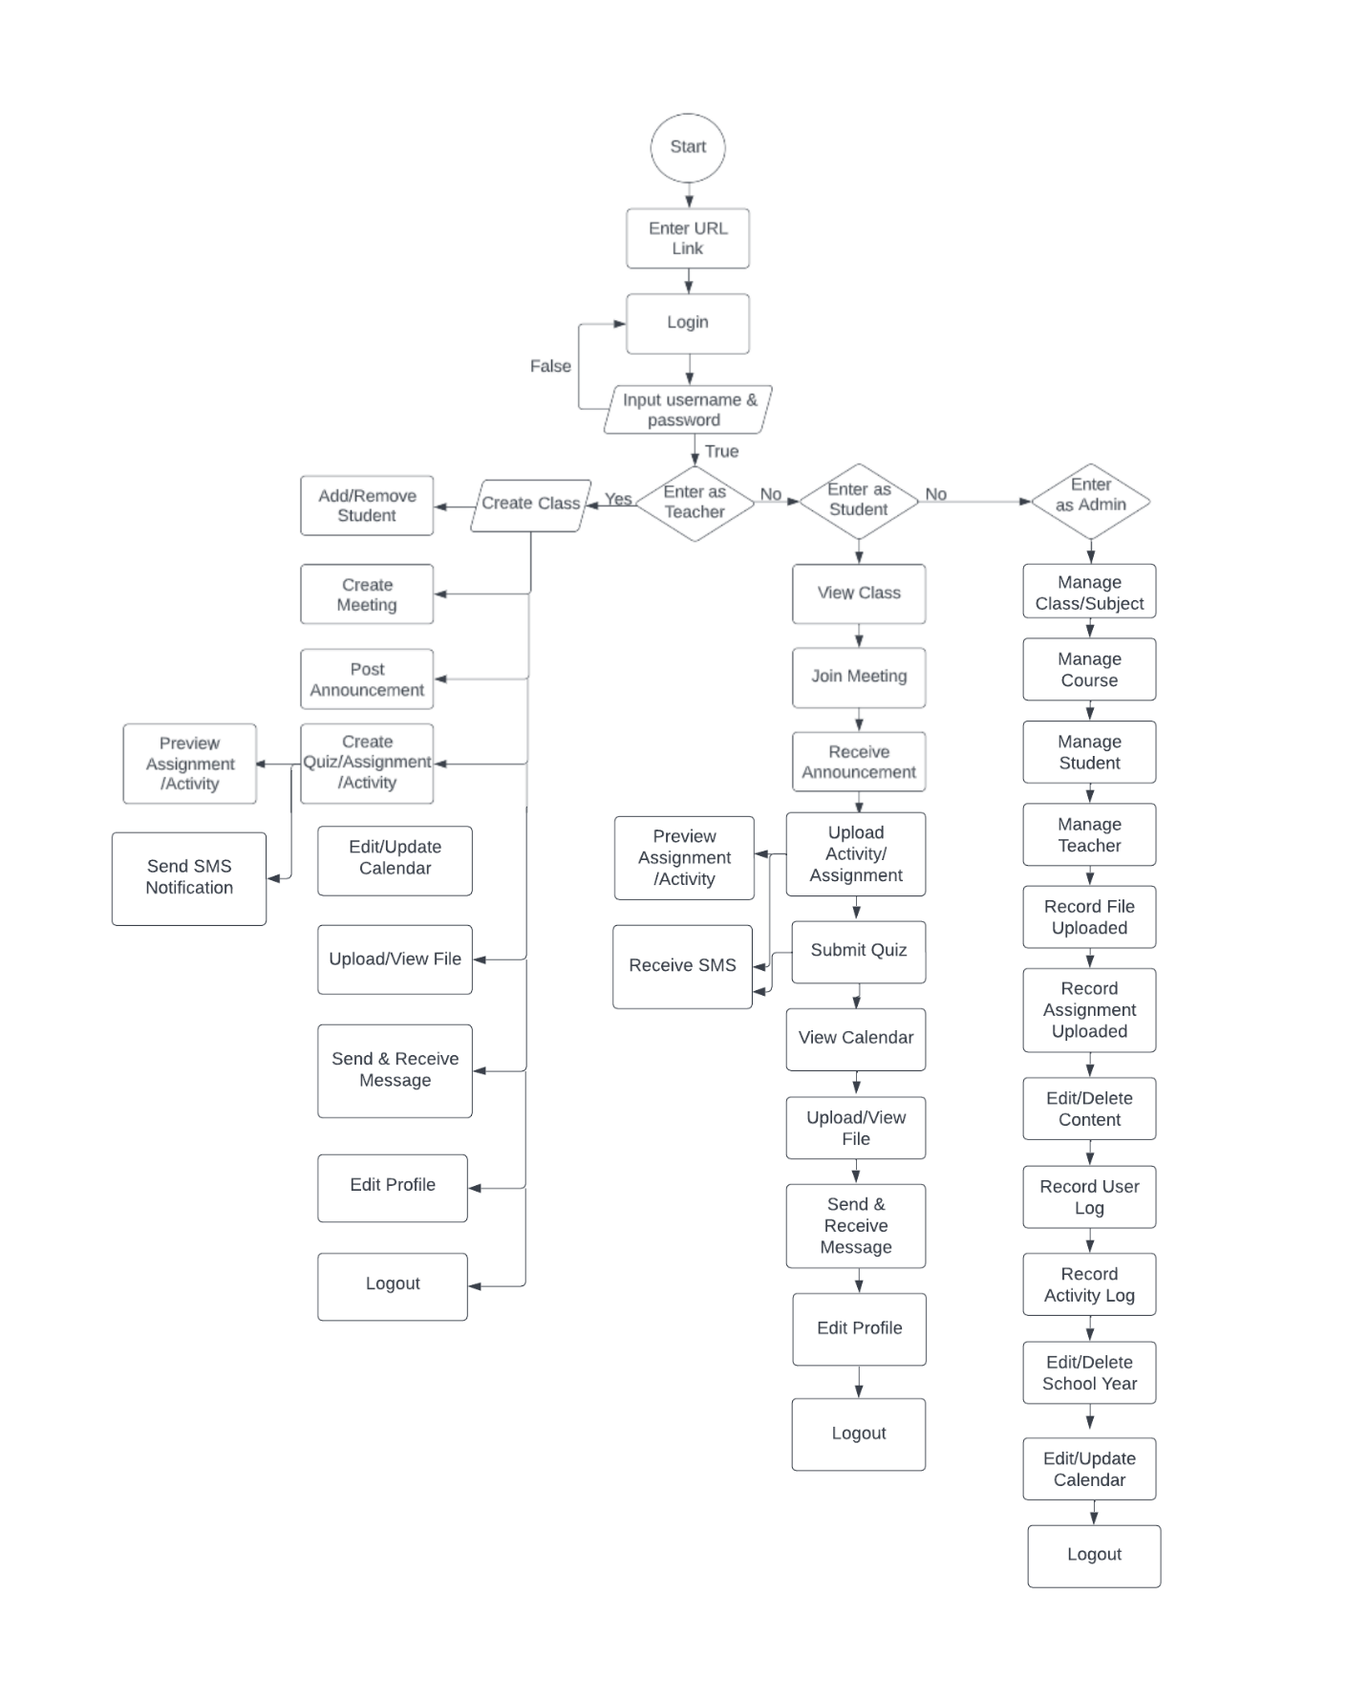

**Figure 4.10**

**Process Flow**

The figure displays the system's processes. It displays the system's beginning position as well as its sequential steps. It begins with how the user must enter the website link to begin the system flow.  It includes the databases and how the data stored will be then showed in the student process.

## **Description of Prototype**

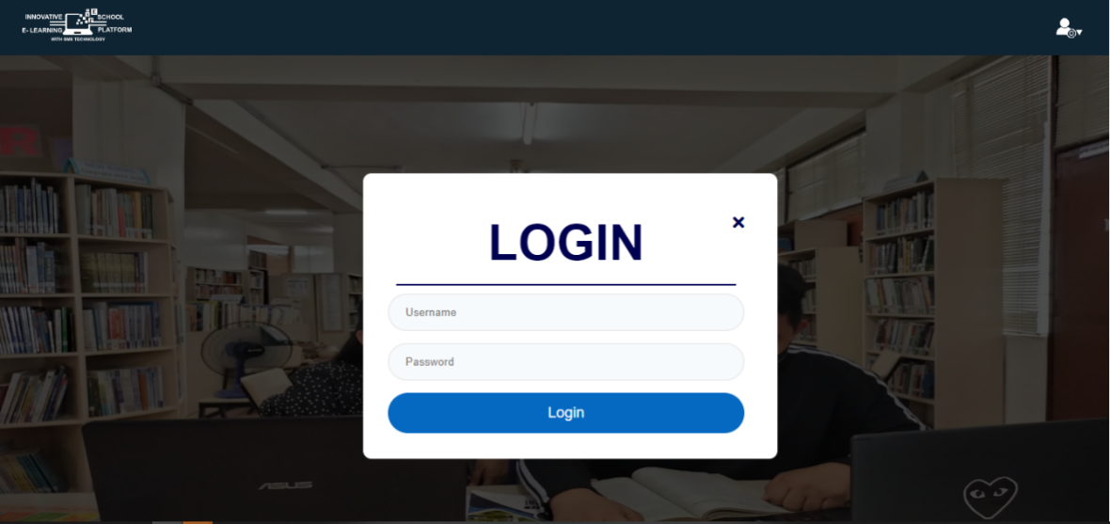

**Figure 4.11**

**Screenshot of the Login Menu**

This picture shows the prototype of the login page. It is created so that the user will be able to access the system. This is where the admin will login to access the admin page.

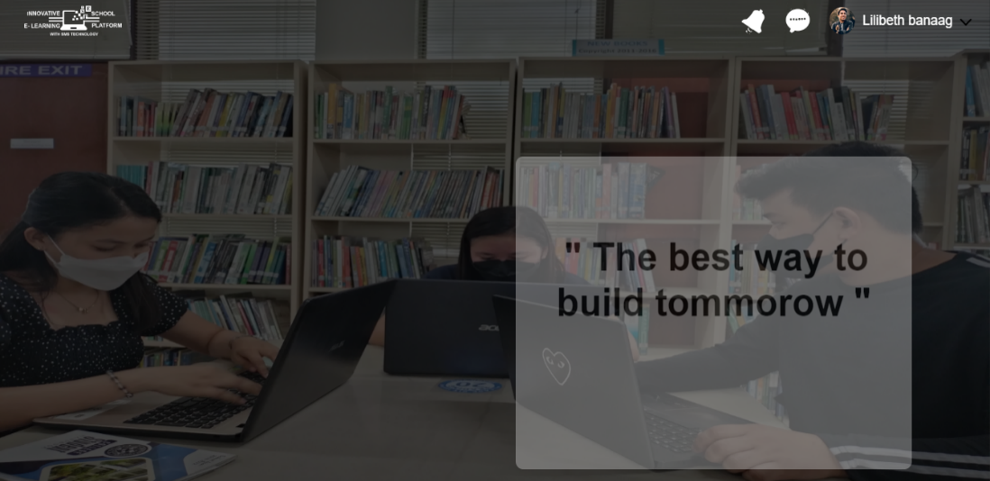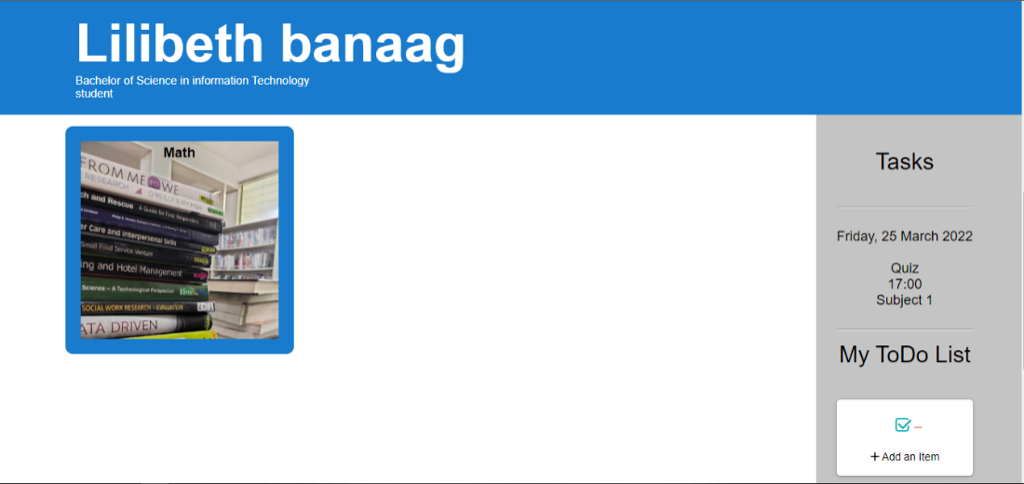

**Figure 4.12**

**Screenshot of the Homepage of student**

This picture shows the prototype of the Homepage of Student. In this page the student will be able to view the subjects, set a To-do list and the tasks that you need to do. This is the page that will appear when the student logs in.

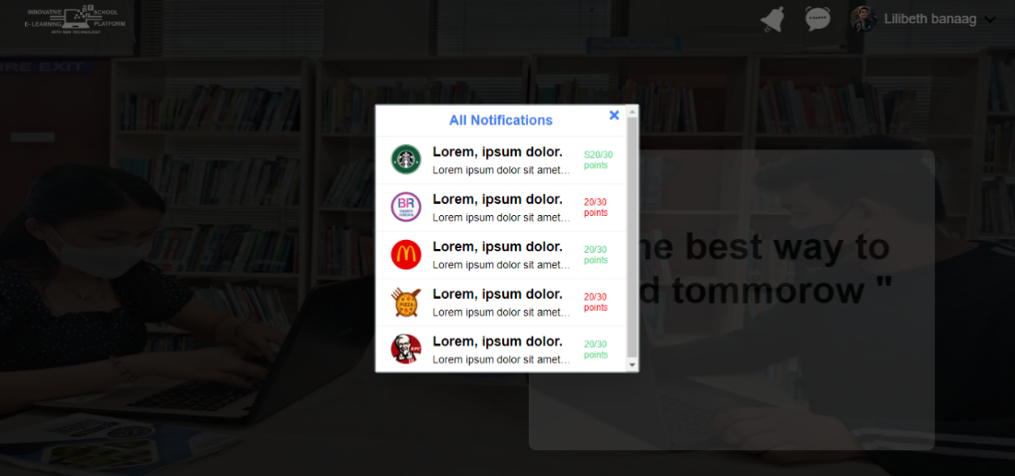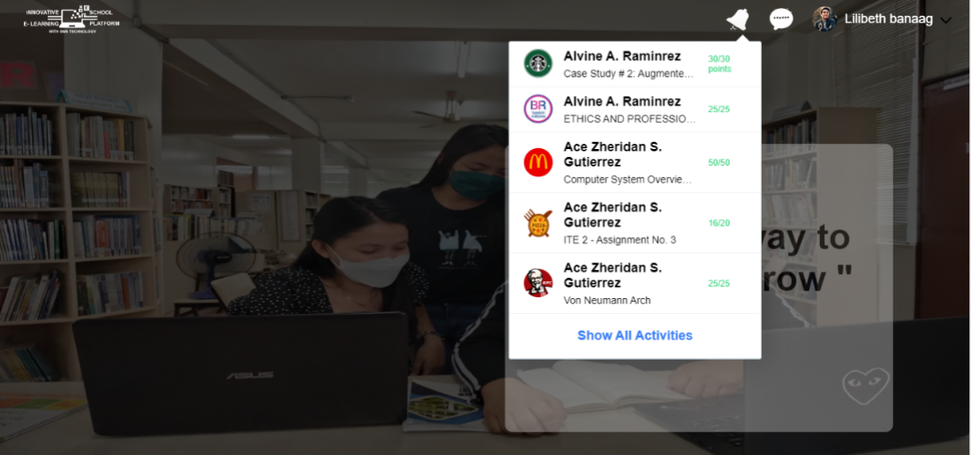

**Figure 4.13**

**Screenshot of the Notification bar**

This picture shows the prototype of the Notification Bar. In this bar this shows all the notifications that the student has. this bar this will appear if the student clicks the notification icon, and this will be the notification bar or the page.

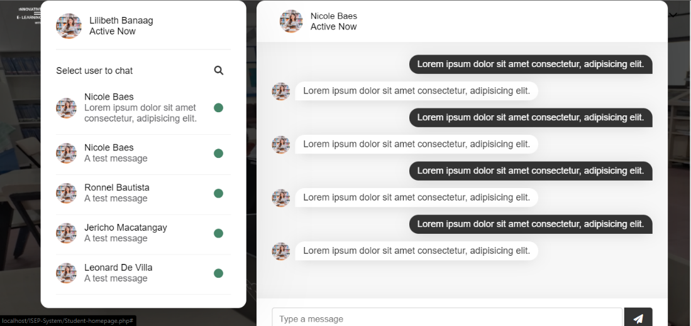

**Figure 4.14**

**Screenshot of the Chat Bar**

This picture shows the prototype of the Chat Bar. The purpose of this bar is to have communications to different users. This will appear when the user clicks on the chat bar.

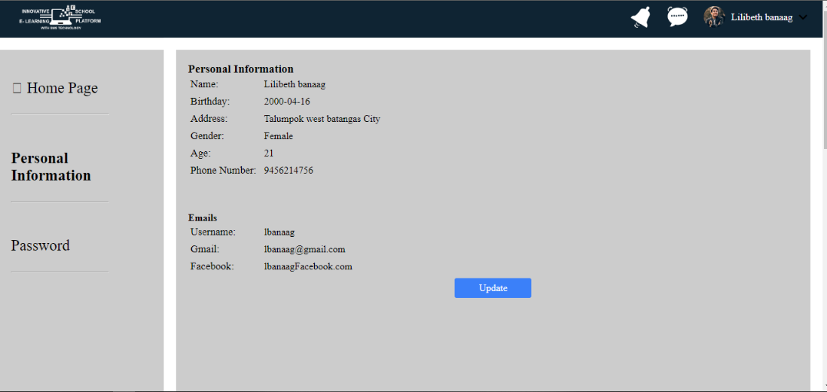

**Figure 4.15**

**Screenshot of the Personal Information Page**

This picture shows the prototype of the Personal Information Page. This page is for the viewing of personal information of the users. This page can be shown when the user clicks on the name at the upper right corner.

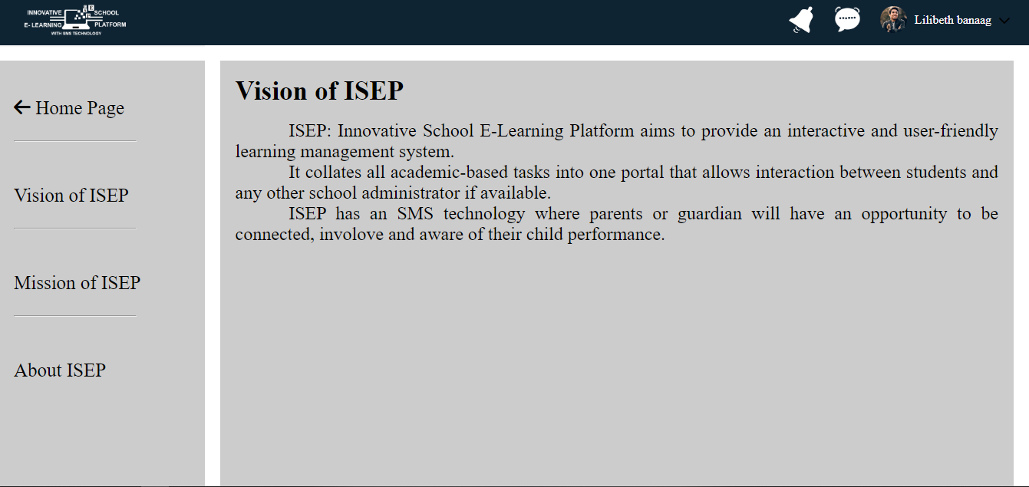

**Figure 4.16**

**Screenshot of the About Page**

This picture shows the prototype of the About page. This page is for viewing information about the page or the ISEP (Innovative School E Learning Platform) website.

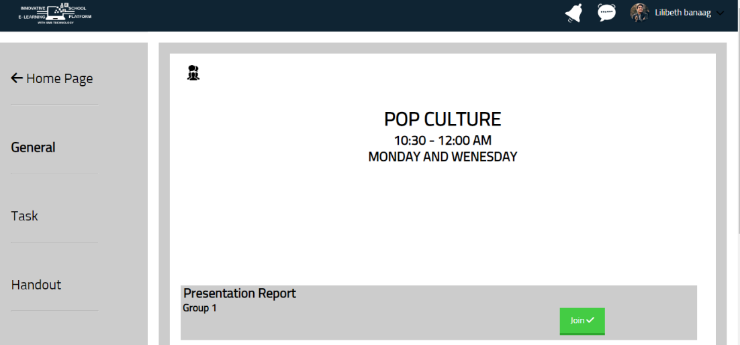

**Figure 4.17**

**Screenshot of the Student General Page**

This picture shows the prototype of the student general page. It is created so that the student will be able to see if the teacher started a meeting. This is where the student can join their meeting.

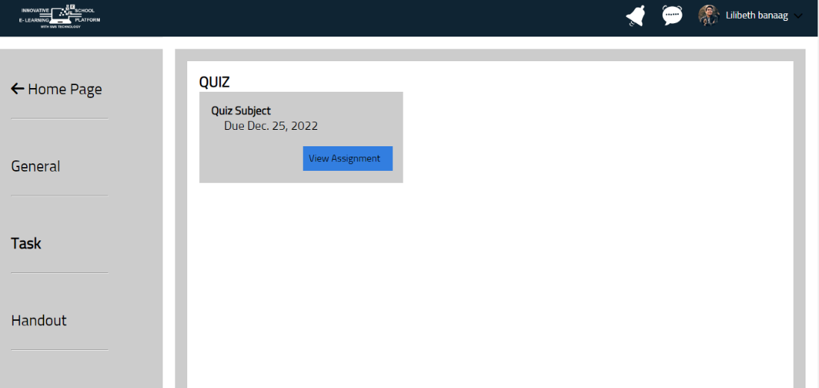

**Figure 4.18**

**Screenshot of the View Tasks**

This picture shows the prototype of the view tasks. It is created so that students can view the activities given by their teachers. This is where the students see the details of the activities given by the teacher.

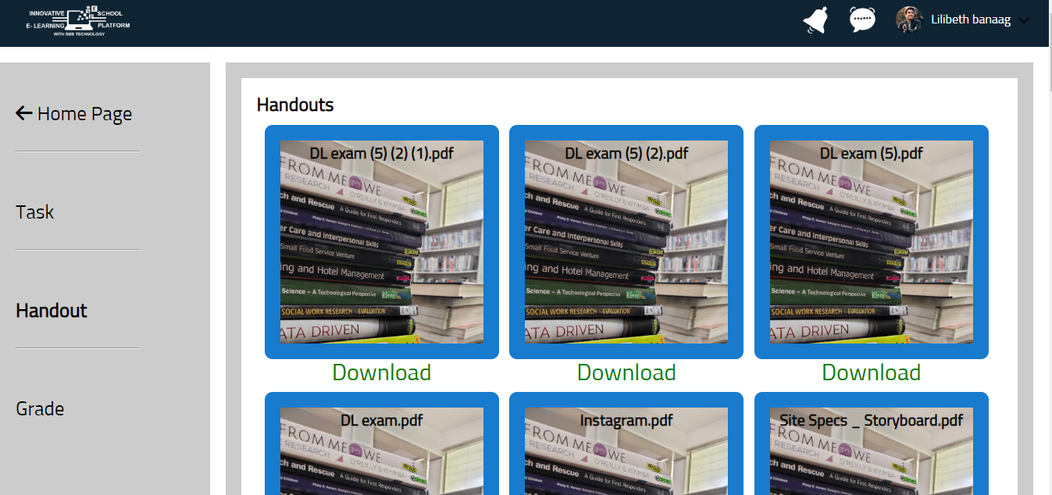

**Figure 4.19**

**Screenshot of the Handout Page**

This picture shows the prototype of the handout page. It is created so that the student can download the file sent by the teacher.

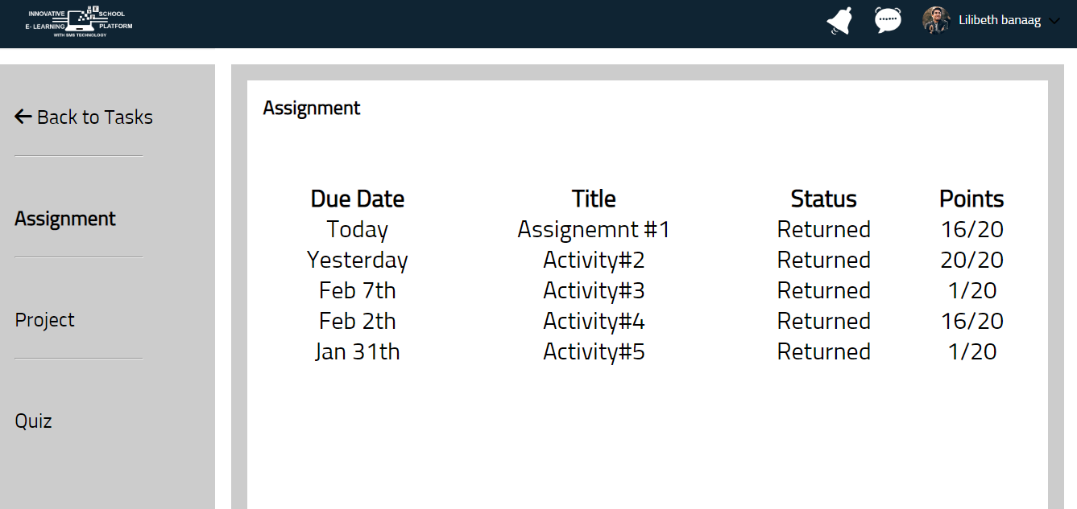

**Figure 4.20**

**Screenshot of the Grading Tasks of Student Page**

This picture shows the prototype of the Grading Tasks of Student Page. It is designed so that the student can keep track of the grades they received from the teacher on the assigned task.

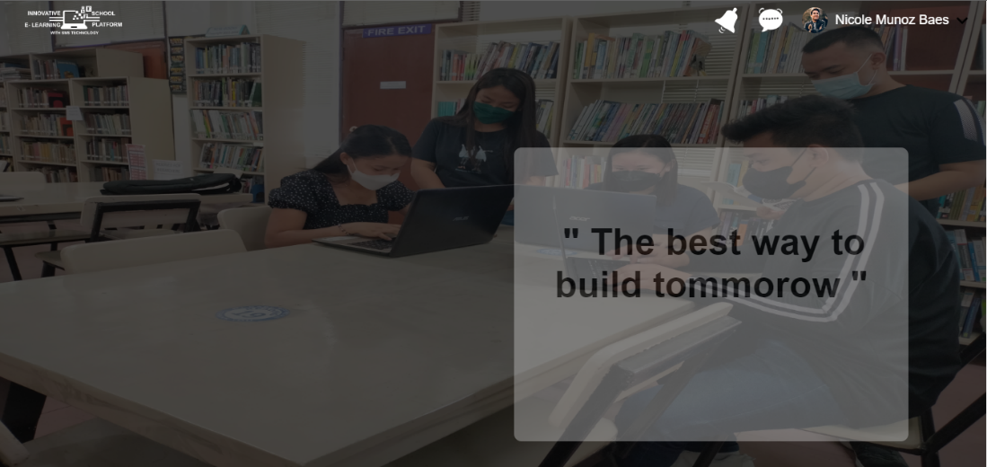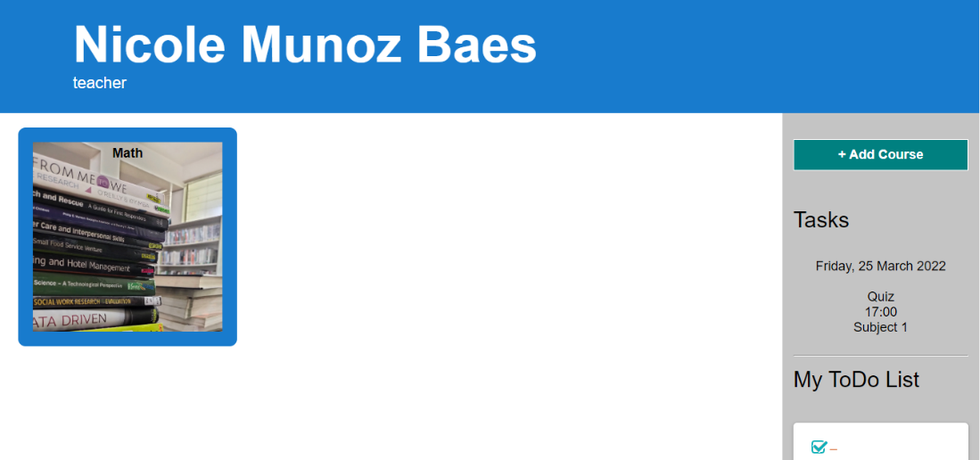

**Figure 4.21**

**Screenshot of the Teacher Home Page**

This picture shows the prototype of the home page for teacher. This is where the teacher can create their class or course that they will be teaching. The Home page also has a to-do list feature. This is where the user can list all the activities or things to do and if they are done, they can mark them checked.

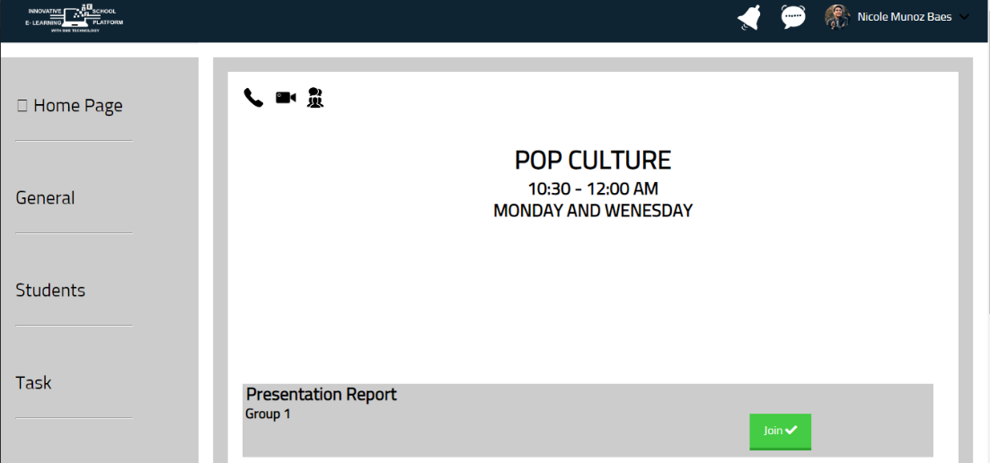

**Figure 4.22**

**Screenshot of the Teacher Subject Home Page**

This picture shows the prototype of the teacher subject home page. This is where the teacher can start their meeting during synchronous classes.

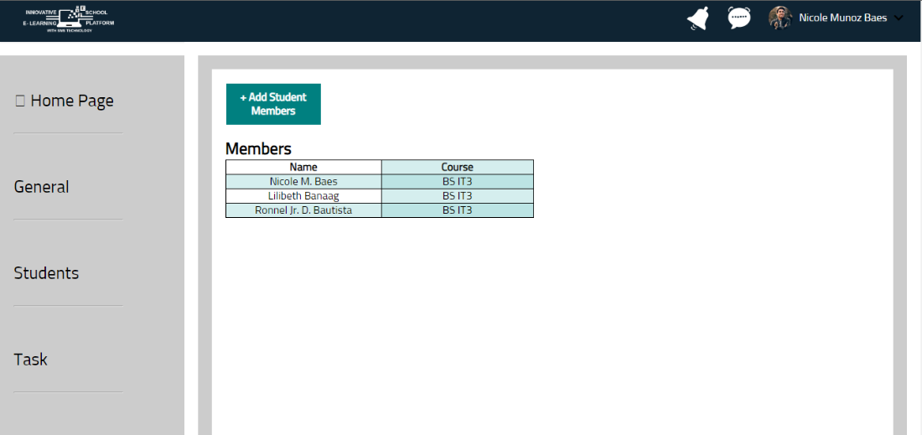

**Figure 4.23**

**Screenshot of the Teacher Adding Students**

This picture shows the prototype of the teacher adding students. It is created so that enrolled students can be added by their teacher. This is where the teacher will add the student who enrolled in their subject.

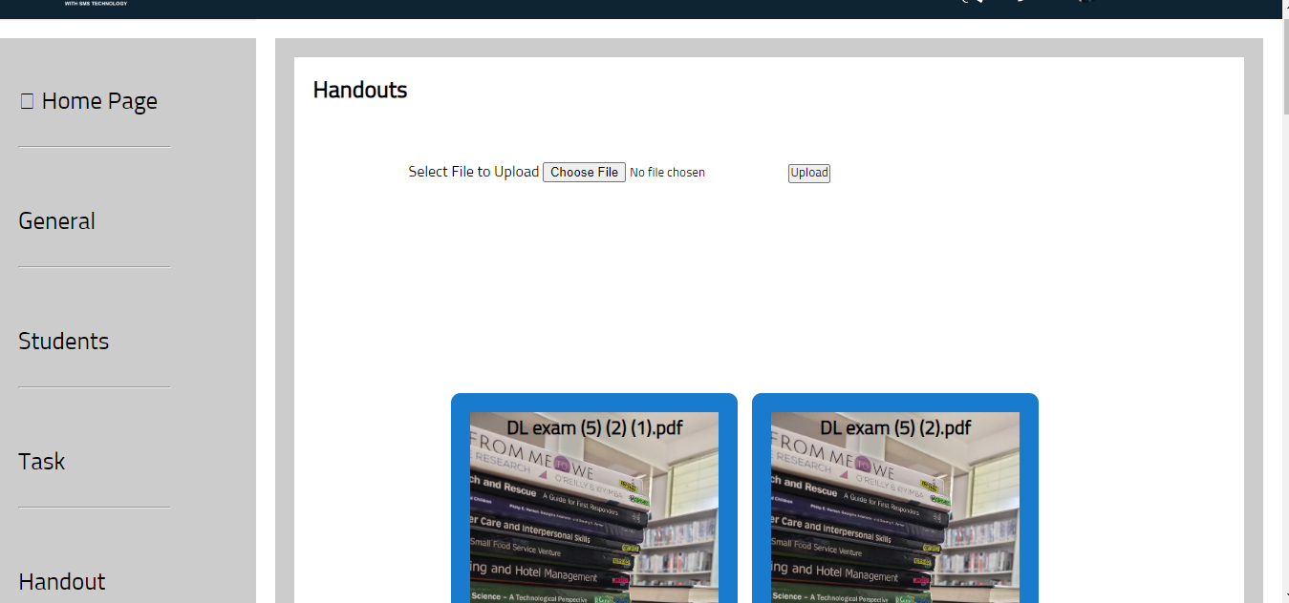

**Figure 4.24**

**Screenshot of the Teacher Handout Page**

This picture shows the prototype of the handout page for teachers. This is where the teacher uploads the files that the students can download.

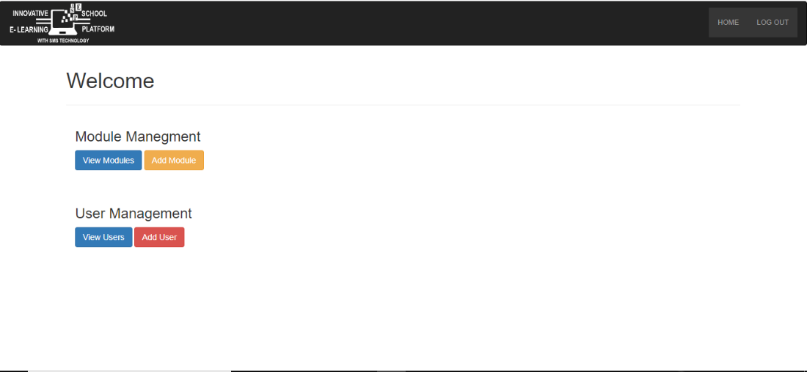

**Figure 4.25**

**Screenshot of the Admin Home Page**

This picture shows the prototype of the admin home page. It is created as a welcome page for the admin. This is where the admin can control and manage the module and user of the ISEP.

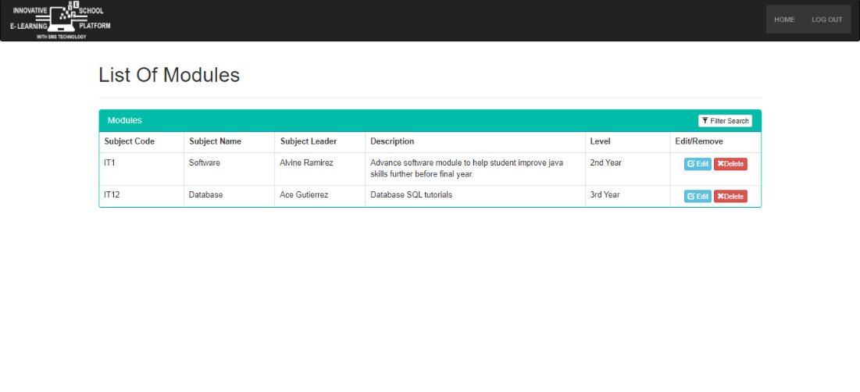

**Figure 4.26**

**Screenshot of the Module Management Page**

This picture shows the prototype of the module management page. This is where the admin can see the list of the modules or subjects for this school or academic year. The admin can see the details of this subject on this page.

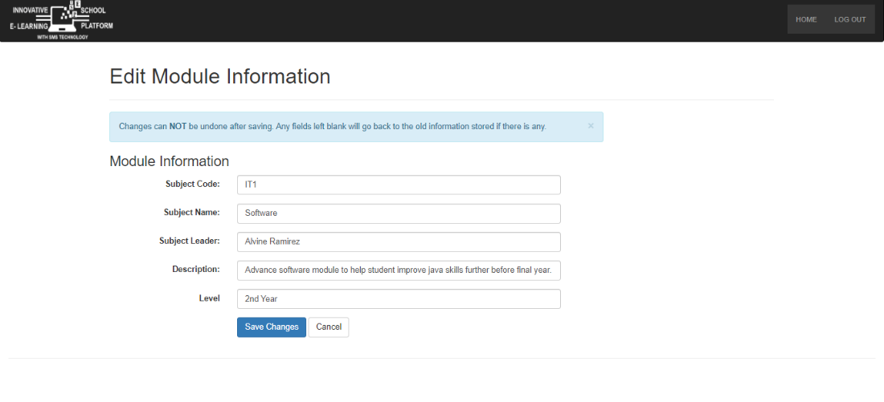

**Figure 4.27**

**Screenshot of the Updating or Editing Module Page**

This picture shows the prototype of updating or editing a subject. It is created so that the admin can update information about subjects. This is where the admin updates or edits the subject information.

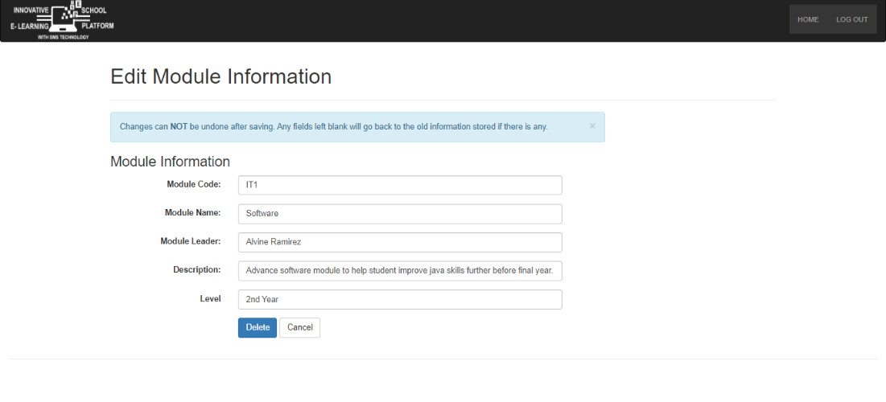

**Figure 4.28**

**Screenshot of the Deleting a Module Page**

This picture shows the prototype of deleting a subject. This is where the admin deletes the subject information.

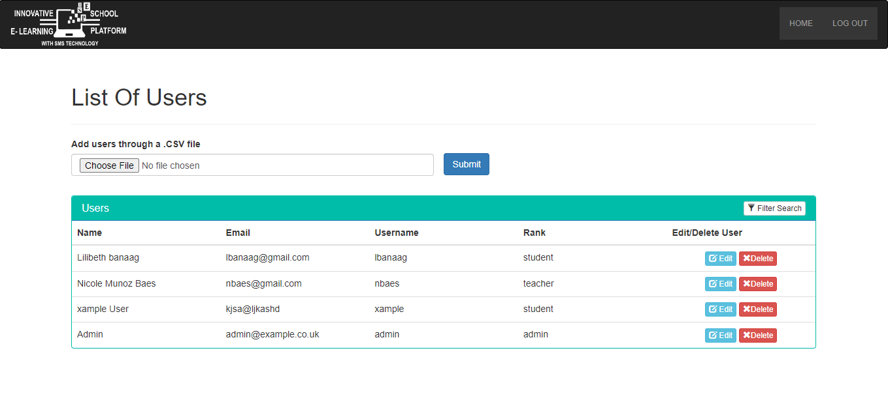

**Figure 4.29**

**Screenshot of the Admin’s List of Users**

This picture shows the prototype of the admin’s list of users. This is where the admin can see the list of ISEP users. The admin can also add a list of users by uploading a .csv file of the user list.

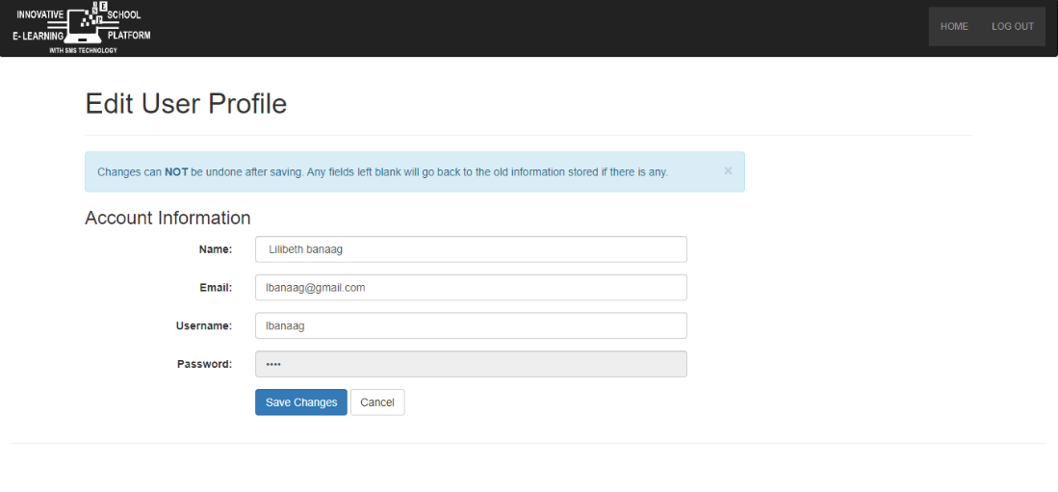

**Figure 4.30**

**Screenshot of the Updating or Editing User Page**

This picture shows the prototype of updating or editing a user page. It is created so that the admin can update information about students. This is where the admin updates or edits the user information.

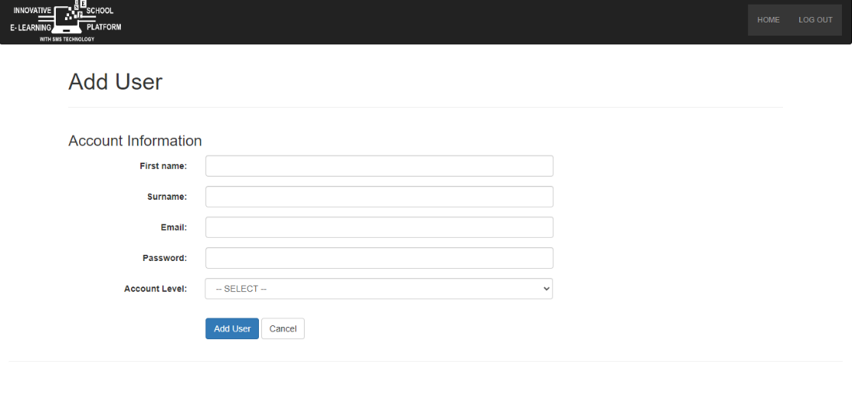

**Figure 4.31**

**Screenshot of an Admin Adding Users**

This picture shows the prototype of an admin adding student. It is created so that the admin can add a user to the system. This is where the admin puts all the necessary information to add users.



**Figure 4.32**

**Screenshot of the Teacher Adding Students**

This picture shows the prototype of the teacher adding students. It is created so that enrolled students can be added by their teacher. This is where the teacher will add the student who enrolled in their subject.



**Figure 4.33**

**Screenshot of the Teacher Handout Page**

This picture shows the prototype of the handout page for teachers. This is where the teacher uploads the files that the students can download.



**Figure 4.34**

**Screenshot of the Admin Home Page**

This picture shows the prototype of the admin home page. It is created as a welcome page for the admin. This is where the admin can control and manage the module and user of the ISEP.



**Figure 4.35**

**Screenshot of the Module Management Page**

This picture shows the prototype of the module management page. This is where the admin can see the list of the modules or subjects for this school or academic year. The admin can see the details of this subject on this page.

## **Minimum Hardware Requirements**

**For Android Mobile Phone**

|  |  |
| --- | --- |
|  | **Type/Specification** |
| Processor | ARM |
| Memory | 512 mb of ROM  512 mb of RAM |

**For Laptop/Desktop**

|  |  |
| --- | --- |
| **Equipment** | **Type/Specification** |
| Processor | Pentium |
| Memory | 2.93 GHz |

**Table 4.1**

**Minimum Hardware Requirements**

The hardware specifications for the system for a desktop computer or laptop, and Android mobile device are shown in the table below. The purpose of these hardware specifications is to let users know what hardware is required for the system to operate properly.

## **Minimum Software Requirements**

**For Android Mobile Phone**

|  |  |
| --- | --- |
|  | **Type/Specification** |
| Version | Android 4.0 Jellybean and up |
| Browser (WebKit) | 534.30 |

**For Laptop/Desktop**

|  |  |
| --- | --- |
| **Equipment** | **Type/Specification** |
| OS | Windows Environment |
| Browser | Google Chrome  Mozilla Firefox  Internet Explorer |

**Table 4.2**

**Minimum Software Requirements**

This table displays the system's software requirements for desktop computers, laptops, as well as Android devices. These programs are necessary for the system to operate and be utilized.

## **Development and Testing**

The proposed system, called ISEP, is a learning management system solution that offers users the accessibility and adaptability they require to maintain normalcy in their daily lives. This website application aims to use SMS technology to provide information, activity, and event announcements to the targeted recipients, tangibly assisting the academic institution. The system was developed using the SDLC (System Development Life Cycle) and the Agile Model. The SDLC is the approach that the proponents use to create the system in order to achieve their objectives.

The proponents use different tools in developing their system like Xampp to make it be more service able and handy to use. The system was designed and developed using the scripting languages and programming tools HTML, CSS, PHP, Bootstrap, and JavaScript. Initially, the developer’s work focused on the selected pilot school which is St. Bridget College. Users of desktop and laptop computers can visit the URL on the website created by the proponents.

The system was tested by the beneficiaries, which included varied teachers and students from various courses and faculties. The system's workings were clearly laid out by the proponents while being actually experienced by the beneficiaries. After testing the system, the respondents also provided feedback on the evaluation instrument. According to the evaluation's findings, each of the questionnaire's categories had a high weighted mean. The verbal interpretation of Strongly Agree resulted in a weighted average score of 3.76 for the student category. On the other hand, the system received a blank weighted mean with a verbal interpretation for the admin category. This showed that the system is operational, functional, and has fulfilled its goals.

This section provides, examines, and interprets the data collected by using the Likert scale. The proponents collected this data from the 46 respondents, rating the system user interface, functionality, security, efficiency, reliability, and accessibility.

## **Student**

**Table 4.3**

**User Interface**

|  |  |  |  |
| --- | --- | --- | --- |
| **ITEMS** | **WM** | **VI** | **Rank** |
| 1. The page background color and font colors are distraction free. | 3.57 | **SA** | **5** |
| 1. The buttons are in proper format and size. | 3.57 | **SA** | **5** |
| 1. The images are in proper position and in high quality. | 3.65 | **SA** | **3** |
| 1. There is ease in identifying the options to select. | 3.57 | **SA** | **5** |
| 1. The font style and font size is appropriate to the fonts and background color. | 3.63 | **SA** | **4** |
| 1. The system is simple and easy to understand. | 3.72 | **SA** | **1** |
| 1. The system interface is user friendly. | 3.65 | **SA** | **3** |
| 1. The icon buttons helps the user to easily determine the functions. | 3.67 | **SA** | **2** |
| 1. The layout of the system is consistent. | 3.65 | **SA** | **3** |
| The system can help the student in reminding them of their status of learning assessment through SMS technology. | 3.65 | **SA** | **3** |
| **Overall Weighted Mean** | **3.63** | **SA** |  |

**Legend:**

**WM – Weighted Mean Range:**

**VI – Verbal Interpretation** **3.60– 4.00 (SA)**

**SA – Strongly Agree** **2.60 – 3.50 (A)**

**1.60 – 2.50 (D)**

**1.00 – 1.50 (SD)**

User interface refers to the means by which a user and a computer system communicate, especially when using an input device and software. The table shows that the respondents strongly agree with the system's user interface, as indicated by the composite mean of 3.63. In particular, the highest rank demonstrated how user-friendly the system interface is.

**Table 4.4**

**Functionality**

|  |  |  |  |
| --- | --- | --- | --- |
| **ITEMS** | **VM** | **VI** | **Rank** |
| 1. Each buttons are working according to their function. | 3.67 | **SA** | **3** |
| 1. Ability to execute the buttons correctly. | 3.67 | **SA** | **3** |
| 1. Ability to view necessary information. | 3.67 | **SA** | **3** |
| 1. Ability to receive SMS notification. | 3.57 | **SA** | **6** |
| 1. Ability to view the schedule in calendar. | 3.67 | **SA** | **3** |
| 1. Ability to answer/respond in assigned learning assessments. | 3.63 | **SA** | **5** |
| 1. Ability to delivers learning materials. | 3.54 | **A** | **7** |
| 1. Ability to participate in synchronous learning mode through video conferencing. | 3.70 | **SA** | **2** |
| 1. System can perform the required task. | 3.74 | **SA** | **1** |
| 1. Ability to monitor their own progress and performance in the course. | 3.65 | **SA** | **4** |
| **Overall Weighted Mean** | **3.65** | **SA** |  |

**Legend:**

**WM – Weighted Mean Range:**

**VI – Verbal Interpretation** **3.60– 4.00 (SA)**

**SA – Strongly Agree** **2.60 – 3.50 (A)**

**1.60 – 2.50 (D)**

**1.00 – 1.50 (SD)**

The variety of operations that can be carried out by a computer or other electronic device is referred to as functionality. The table shows that, as indicated by the composite mean of 3.65, the respondents strongly agreed that the system worked as intended. The highest rank in particular demonstrated that the system can view necessary information, send notifications, and load pages efficiently.

**Table 4.5**

**Security**

|  |  |  |  |
| --- | --- | --- | --- |
| **ITEMS** | **VM** | **VI** | **Rank** |
| 1. The system provides enough security for the account information of the users. | 3.54 | **A** | **5** |
| 1. The system requires strong password for the authenticity of the user. | 3.63 | **SA** | **3** |
| 1. There is a separate account for each kind of user (student, teacher, admin) | 3.61 | **SA** | **4** |
| 1. The system provides safety measurement of the file uploaded. | 3.72 | **SA** | **2** |
| 1. The system prevents unauthorized access (in login) | 3.63 | **SA** | **3** |
| 1. The system provides account security for users. | 3.73 | **SA** | **1** |
| **Overall Weighted Mean** | **3.67** | **SA** |  |

**Legend:**

**WM – Weighted Mean Range:**

**VI – Verbal Interpretation** **3.60– 4.00 (SA)**

**SA – Strongly Agree** **2.60 – 3.50 (A)**

**1.60 – 2.50 (D)**

**1.00 – 1.50 (SD)**

Security is a characteristic or a condition of being secure. The composite mean of 3.67 in the table indicates that the respondents strongly agreed with the system's security. The highest rank in particular demonstrated that the system includes password constraints for user validity.

**Table 4.6**

**Reliability**

|  |  |  |  |
| --- | --- | --- | --- |
| **ITEMS** | **VM** | **VI** | **Rank** |
| 1. The system loads each page quickly. | 3.72 | **SA** | **2** |
| 1. The system gives correct information. | 3.54 | **SA** | **3** |
| 1. The system provides adequate information. | 3.76 | **SA** | **1** |
| **Overall Weighted Mean** | **3.67** | **SA** |  |

**Legend:**

**WM – Weighted Mean Range:**

**VI – Verbal Interpretation** **3.60– 4.00 (SA)**

**SA – Strongly Agree** **2.60 – 3.50 (A)**

**1.60 – 2.50 (D)**

**1.00 – 1.50 (SD)**

Reliability is the characteristic of being trustworthy of operating consistently effectively. The table shows that the respondents strongly agreed that the system was reliable, as indicated by the composite score of 3.67. The highest rank in particular demonstrated that the system offers adequate information.

**Table 4.7**

**Efficiency**

|  |  |  |  |
| --- | --- | --- | --- |
| **ITEMS** | **VM** | **VI** | **Rank** |
| 1. The application improves the user's time management. | 3.52 | **A** | **3** |
| 1. Ability of the system to encourage the users to keep using it. | 3.59 | **SA** | **2** |
| 1. Ability to produce correct information. | 3.65 | **SA** | **1** |
| 1. Ability of the system to respond quickly | 3.52 | **A** | **3** |
| 1. Ease and straightforwardness of performing tasks. | 3.65 | **SA** | **1** |
| 1. Ability to handle large file or document. | 3.65 | **SA** | **1** |
| **Overall Weighted Mean** | **3.59** | **SA** |  |

**Legend:**

**WM – Weighted Mean Range:**

**VI – Verbal Interpretation** **3.60– 4.00 (SA)**

**SA – Strongly Agree** **2.60 – 3.50 (A)**

**1.60 – 2.50 (D)**

**1.00 – 1.50 (SD)**

Efficiency is a quality or state of efficiency. The table shows that, according to the composite mean of 3.59, the respondents strongly agree with the system's efficiency. Particularly, the highest rank demonstrated the system's capacity to persuade people to continue using it.

**Table 4.8**

**Accessibility**

|  |  |  |  |
| --- | --- | --- | --- |
| **ITEMS** | **VM** | **VI** | **Rank** |
| 1. The application is compatible in any web browser and in android mobile phone and other devices. | 3.67 | **SA** | **2** |
| 1. The system can be open even with the low connectivity. | 3.63 | **SA** | **3** |
| 1. Ability to produce correct information. | 3.73 | **SA** | **1** |
| **Overall Weighted Means** | **3.67** | **SA** |  |

**Legend:**

**WM – Weighted Mean Range:**

**VI – Verbal Interpretation** **3.60– 4.00 (SA)**

**SA – Strongly Agree** **2.60 – 3.50 (A)**

**1.60 – 2.50 (D)**

**1.00 – 1.50 (SD)**

Being able to be reached or entered is a feature that is referred to as accessibility. The composite mean of 3.67 in the table indicates that the respondents agreed the system's accessibility. The highest rank in particular demonstrated that the system works with any web browser, an android phone, and other devices and produces accurate information.

This section provides, examines, and interprets the data collected by using the Likert scale. The proponents collected this data from the 10 respondents, rating the system user interface, functionality, security, efficiency, reliability, and accessibility.

## **Teacher**

**Table 4.9**

**User Interface**

|  |  |  |  |
| --- | --- | --- | --- |
| **ITEMS** | **WM** | **VI** | **Rank** |
| The page background color and font colors are distraction free. | 3.60 | **SA** | **4** |
| The buttons are in proper format and size. | 3.70 | **SA** | **3** |
| The images are in proper position and in high quality. | 3.70 | **SA** | **3** |
| There is ease in identifying the options to select. | 3.50 | **A** | **5** |
| The font style and font size is appropriate to the fonts and background color. | 3.80 | **SA** | **2** |
| The system is simple and easy to understand. | 3.50 | **A** | **5** |
| The system can help the teacher to remind the students of their status of learning assessment through SMS technology. | 3.90 | **SA** | **1** |
| The system interface is user friendly. | 3.80 | **SA** | **2** |
| The icon buttons helps the user to easily determine the functions. | 3.60 | **SA** | **4** |
| The layout of the system is consistent. | 3.60 | **SA** | **4** |
| The system can access in different devices. | 3.70 | **SA** | **3** |
| **Overall Weighted Mean** | **3.67** | **SA** |  |

**Legend:**

**WM – Weighted Mean Range:**

**VI – Verbal Interpretation** **3.60– 4.00 (SA)**

**SA – Strongly Agree** **2.60 – 3.50 (A)**

**1.60 – 2.50 (D)**

**1.00 – 1.50 (SD)**

User interface refers to the means by which a user and a computer system communicate, especially when using an input device and software. The composite mean of 3.67 in the table indicates that the respondents had a high level of agreement with the system's user interface. The respondents proved that the system interface is user friendly.

**Table 4.10**

**Functionality**

|  |  |  |  |
| --- | --- | --- | --- |
| **ITEMS** | **VM** | **VI** | **Rank** |
| Each buttons are working according to their function. | 3.80 | **SA** | **1** |
| Ability to execute the buttons correctly. | 3.80 | **SA** | **1** |
| Ability to view important files and documents shared by the student on the platform. | 3.60 | **SA** | **3** |
| 1. Ability to send SMS notification. | 3.50 | **A** | **4** |
| Ability to make a schedule in calendar. | 3.60 | **SA** | **3** |
| Ability to create/respond assessments. | 3.60 | **SA** | **3** |
| Ability to track student’s academic record. | 3.50 | **A** | **4** |
| Ability to delivers learning materials. | 3.60 | **SA** | **3** |
| Ability to monitor student’s progress and performance in the course. | 3.40 | **A** | **5** |
| Ability to support synchronous learning mode through video conferencing. | 3.70 | **SA** | **2** |
| System can perform the required task. | 3.60 | **SA** | **3** |
| **Overall Weighted Mean** | **3.55** | **A** |  |

**Legend:**

**WM – Weighted Mean Range:**

**VI – Verbal Interpretation** **3.60– 4.00 (SA)**

**SA – Strongly Agree** **2.60 – 3.50 (A)**

**1.60 – 2.50 (D)**

**1.00 – 1.50 (SD)**

The variety of operations that can be carried out by a computer or other electronic device is referred to as functionality. The table shows that, as indicated by the composite mean of 3.55, the respondents agreed that the system worked as intended. Particularly, the respondents acknowledge that the system can support synchronous learning mode through video conferencing, create/respond in assessment, deliver learning materials, view important file shared by the student, send SMS notification regarding their missed dues or activity.

**Table 4.11**

**Security**

|  |  |  |  |
| --- | --- | --- | --- |
| **ITEMS** | **VM** | **VI** | **Rank** |
| 1. The system provides enough security for the account information of the users. | 3.80 | **SA** | **1** |
| 1. The system requires strong password for the authenticity of the user. | 3.60 | **SA** | **3** |
| 1. There is a separate account for each kind of user (student, teacher, admin) | 3.70 | **SA** | **2** |
| The system provides safety measurement of the file uploaded. | 3.70 | **SA** | **2** |
| The system prevents unauthorized access (in login) | 3.60 | **SA** | **3** |
| The system provides account security for users. | 3.60 | **SA** | **3** |
| **Overall Weighted Mean** | **3.67** | **SA** |  |

**Legend:**

**WM – Weighted Mean Range:**

**VI – Verbal Interpretation** **3.60– 4.00 (SA)**

**SA – Strongly Agree** **2.60 – 3.50 (A)**

**1.60 – 2.50 (D)**

**1.00 – 1.50 (SD)**

Security is a property or a condition of being secure. The composite mean of 3.67 in the table indicates that the respondents strongly agreed with the system's security. The highest rank in particular demonstrated that the system includes password constraints for user validity.

**Table 4.12**

**Reliability**

|  |  |  |  |
| --- | --- | --- | --- |
| **ITEMS** | **VM** | **VI** | **Rank** |
| 1. The system loads each page quickly. | 3.50 | **A** | **3** |
| 1. The system gives correct information. | 3.70 | **SA** | **1** |
| 1. The system provides adequate information. | 3.60 | **SA** | **2** |
| **Overall Weighted Mean** | **3.60** | **SA** |  |

**Legend:**

**WM – Weighted Mean Range:**

**VI – Verbal Interpretation** **3.60– 4.00 (SA)**

**SA – Strongly Agree** **2.60 – 3.50 (A)**

**1.60 – 2.50 (D)**

**1.00 – 1.50 (SD)**

Reliability is the characteristic of being trustworthy of operating consistently effectively. The table shows that the respondents strongly agreed that the system was reliable, as indicated by the composite score of 3.60. The highest rank in particular demonstrated that the system offers adequate information.

**Table 4.13**

**Efficiency**

|  |  |  |  |
| --- | --- | --- | --- |
| **ITEMS** | **VM** | **VI** | **Rank** |
| 1. The application improves the user's time management. | 3.40 | **A** | **4** |
| 1. Ability of the system to encourage the users to keep using it. | 3.70 | **SA** | **1** |
| 1. Ability to produce correct information. | 3.60 | **SA** | **2** |
| Ability of the system to respond quickly | 3.50 | **A** | **3** |
| Ease and straightforwardness of performing tasks. | 3.30 | **A** | **5** |
| Ability to handle large file or document. | 3.00 | **A** | **6** |
| **Overall Weighted Mean** | **3.42** | **A** |  |

**Legend:**

**WM – Weighted Mean Range:**

**VI – Verbal Interpretation** **3.60– 4.00 (SA)**

**SA – Strongly Agree** **2.60 – 3.50 (A)**

**1.60 – 2.50 (D)**

**1.00 – 1.50 (SD)**

Efficiency is a quality or state of efficiency. The table shows that, according to the composite mean of 3.42, the respondents agree with the system's efficiency. Particularly, the highest rank demonstrated the system's capacity to persuade people to continue using it.

**Table 4.14**

**Accessibility**

|  |  |  |  |
| --- | --- | --- | --- |
| **ITEMS** | **VM** | **VI** | **Rank** |
| 1. The application is compatible in any web browser and in android mobile phone and other devices. | 3.50 | **A** | **1** |
| 1. The system can be open even with the low connectivity. | 3.50 | **A** | **1** |
| 1. Ability to produce correct information. | 3.40 | **A** | **2** |
| **Overall Weighted Means** | **3.47** | **A** |  |

**Legend:**

**WM – Weighted Mean Range:**

**VI – Verbal Interpretation** **3.60– 4.00 (SA)**

**SA – Strongly Agree** **2.60 – 3.50 (A)**

**1.60 – 2.50 (D)**

**1.00 – 1.50 (SD)**

Being able to be reached or entered is a feature that is referred to as accessibility. The composite mean of 3.47 in the table indicates that the respondents agreed the system's accessibility. The highest rank in particular demonstrated that the system works with any web browser, an android phone, and other devices and produces accurate information.

## **Implementation Plan**

The capstone project entitled, “ISEP: Innovative School E-learning Platform with SMS Technology” tested by its main beneficiaries. The proponents of the website application should conduct orientation and training to the application's expected users. The application's proponents intended to orient and educate the users by explaining to them how they will be able to utilize it and how it works before allowing them to use and access it on their own.

The application is intended to be implemented to the users once it is done and fully working. The output of the assessment for the students and the teacher will be evaluated to determine whether it is beneficial and has an effect on the beneficiaries.

## **Implementation Result**

The capstone project entitled, “ISEP” Innovative School E-learning Platform with SMS Technology was developed for the benefit of students and teachers to offer a better approach of online learning and to make it better for students to use the platform for their studies at St. Bridget College Batangas.

The Likert Scale's four levels of agreement were developed as part of the evaluation tool. This gave the respondents the opportunity to identify how strongly they agreed or disagreed with a particular statement. The evaluation tool contains various criteria, including User Interface, Functionality, Security, Reliability, Efficiency, and Accessibility. The evaluation's results showed that practically all of the categories obtained opinions of Strongly Agree (SA) from the students and another Strongly Agree (SA) from the teacher. The verbal interpretation of Strongly Agree resulted in an average weighted mean for the student category of 3.76. (SA). On the other hand, the system received a 3.50 weighted mean for the teacher category with the verbal interpretation of Strongly Agree (SA). This indicated that the system is operating and effective and has satisfied the objectives of the system.

# **SUMMARY, CONCLUSIONS AND RECOMMENDATION**

## **Summary**

The capstone project entitled, “ISEP: Innovative School E-Learning Platform with SMS technology” was developed for the benefit of students and teachers to offer a better approach of online learning and to make it better for students to use the platform for their studies at St. Bridget College Batangas. Through SMS text notifications where the teacher sends a SMS text notification prompting students about project submission and deadlines. This capstone project integrates all the academic-based tasks into a single site that enables synchronous and asynchronous communication between students and teachers. This system is web-based so it can be accessed online using browser by using the system link provided by the proponents.

This website application is designed for distance learning and supports both synchronous and asynchronous learning styles. The findings of the beneficiaries' evaluation of the system indicate that it can significantly improve teaching methods. Being able to better communicate with the students and teachers would be advantageous. This showed that the product is working, functional, and has fulfilled its goals.

## **Conclusion**

The capstone project entitled, "ISEP” An Innovative School E-Learning Platform using SMS technology project was created to improve online learning and the platform's usability for students at St. Bridget College Batangas. With the help of the system, students and teachers will be able to communicate more effectively regarding academic matters with its interactive and user-friendly learning management system.

Based on the result of the evaluation which the total of the respondents answered STRONGLY AGREE on the evaluation categories which answers the objectives of the system. The proponents conclude that:

**1.** The designed system was feasible to implement and used by the beneficiaries based on the overall weighted mean of the evaluation gaining the highest rank which is strongly agree (SA) on the overall category of the evaluation. The system was accepted by the client.

**2**. According to the overall weighted mean of the evaluation, which received the highest rating, strongly agree (SA) on the overall category of the evaluation, the developed system was sufficient and used by the beneficiaries. ISEP provide the need of the student and teacher in terms of online and distance learning.​

**3**. The system was designed and developed by the proponents using the stated objective. It incorporates significant security measures, has user-friendly functionality. Furthermore, it improves the system's user interface while being effective in terms of receiving SMS messages.

The proponents designed and developed a system that is effective for teachers and students to utilize today. The system is capable of creating, modifying, posting announcements, exam schedules, and activities that students were given. Moreover, the technology makes it easy for the administrator to monitor data and information. The main goal of the system's developers is to use SMS technology to notify students of their upcoming due and missed dates for assessments.

4. The system provides capabilities that satisfy the required specifications. According to the evaluation carried out by the proponents, which reached strong agreement (SA) on the evaluation's general category, the developed and implemented system complies with the system requirements.

## **Recommendation**

This capstone project entitled, “ISEP: Innovative School E-Learning Platform with SMS technology” was implemented and accepted by the client. The system has a friendly user interface, implements effective security, and has a mobile-friendly application. With the features and security, still there are things that can be subjected to improvements.

The recommendations suggested by the panel includes ….

## **Bibliography**

Oliveira, E.G. (2012). Distance education in the paradigmatic transition. Papirus, Campinas https://doi.org/10.4301/S1807-17752016000200001

Abbad, M. M., Morris, D. J., & De Nahlik, C. (2009). Looking under the Bonnet: Factors Affecting Student Adoption of E-Learning Systems in Jordan. The International Review of Research in Open and Distributed Learning, 10(2).

Aleke, D., & Akaniyere, B. (2015). An assessment of awareness and use of e-Learning resources by secondary school teachers in the Northeastern State of Yobe, Nigeria. International Journal of Technical Research and Applications, 22(22), 49–54.

Najmul Islam, A. (2016). E-learning system use & its outcomes: Moderating role of perceived compatibility. Telematics & Informatics, 33(1), 48–55. doi:10.1016/j.tele.2015.06.010

Al-khresheh, M. (2020). The impact of cultural background on Listening comprehension of Saudi EFL students. Arab World English Journal, 11(3), 349-371.

Al-Mashaqbeh, I. F. (2009). The use of Blackboard software as a course delivery method. Journal of Educational & Psychological Sciences, 10(3), 12-28.

Al-khresheh, M. (2020). The impact of cultural background on Listening comprehension of Saudi EFL students. Arab World English Journal, 11(3), 349-371.

Butler, D. L., & Sellbom, M. (2002). Barriers to adopting technology for teaching and learning. Educause Quarterly, 8(2), 22-28.

Carrillo, C., & Flores, A. M. (2020). COVID-19 and teacher education: a literature review of online teaching and learning practices. European Journal of Teacher Education, 43(4), 466-487.

Julian, C. C., Toni, D., & Sarah, K. (2019). Lecturers' perceptions and experiences of Blackboard Collaborate as a distance learning and teaching tool via Open Universities Australia (OUA). The Journal of Open, Distance and e-Learning, 35(3), 222-235.

Tschand, M., Mayer, B., & Sorkoa, S. R. (2020). An interdisciplinary digital learning and research factory: The Smart Production Lab. Procedia Manufacturing, 45, 491-496.

Aldosari, H., & Mekheimer, M. (2013) The bandwagon effect in the adoption of e-learning systems in language learning – an appraisal. GSTF Journal on Computing, 2(4), 61-81.

Eldridge, B. (2014). Exploring faculty adoption and utilization of Blackboard at a community college in the Kentucky Community and Technical College System. (Doctoral dissertation), University of Kentucky, USA.

De Clunie, G. T., Clifton, C. T., Castillo, A., & Rangel, N. (2013). Android based mobile environment for moodle users. Proceedings of the IADIS International Conference Mobile Learning 2013, ML 2013, 125–132.

Naz, T., & Khan, M. (2018). Functionality gaps in the design of learning management systems. International Journal of Advanced Computer Science and Applications, 9(11), 371–374.

Almanar, M. A. (2020). The shifting of face to face learning to distance learning during the pandemic Covid-19. Globish (An English-Indonesian Journal for English, Education and Culture), 9(2). <https://doi.org/10.31000/globish.v9i2.2772>.

Dhawan, S. (2020). Online Learning: A Panacea in the Time of COVID-19 Crisis. Journal of Educational Technology Systems, 49(1), 5–22. <https://doi.org/10.1177/0047239520934018>.

Dhir, S. K., Verma, D., Batta, M., & Mishra, D. (2017). E-learning in medical education in India. Indian Pediatrics, 54(10), 871–877. <https://doi.org/10.1007/s13312-017-1152-9>.

Sari, A., & Setiawan, A. (2018). The development of internet-based economic learning media using moodle approach. International Journal of Active Learning, 3(2), 100–109. https://www.learntechlib.org/p/208671/%0A.

Alfonso, G. J. (2012, August). UP Open University: Thoughts about openness in a digitized world [Powerpoint slides]. Presentation at the UPOU Roundtable Discussion, UPOU Oblation Hall, Los Banos, Laguna.

Doctor, A. C. (2017). Integrated educational management tool for Adamson University. International Journal of Computing Sciences Research, 1(1), 52-71.

Urera Jr., F., & Balahadia, F. (2019). ICTeachMUPO: An Evaluation of Information E-Learning Module System for Faculty and Students. International Journal of Computing Sciences Research, 3(1), 163-188.

Cofino, C., Atillo, G., & Velos, S. (2021). e-XTENSION: A Virtual Learning Environment (VLE) System for a State University. International Journal of Computing Sciences Research, 5(1), 663-678.

Mauricio, J. Q., Cagayan, K.B.I., Serrano, J. R. M., Balahadia, F. F., & Sandoval, F.-I.V. (2017). Centralized learning and assessment tool for Department of Education –Division of Laguna’s Araling Panlipunan subjects. International Journal of Computing Sciences Research, 1(2), 21-35. doi:10.25147/ijcsr.2017.001.1.08

Fearnley, M. R & Amora, J. T (2020) Learning Management System Adoption in Higher Education using the Extended Technology Acceptance Model

Tan, A. (2003) The effectiveness of e-learning: More than what you would expect! [philstar.com/business/technology/2003/04/25/203714/effectiveness-e-learning-more-what-you-would-expect](https://www.philstar.com/business/technology/2003/04/25/203714/effectiveness-e-learning-more-what-you-would-expect)

Orani, P.R. “2nd National Conference on E-Learning: Tech-Enabled Education Takes a Big Step Forward.” Metropolitan Computer Times. 5 August 2003.

Rahardja, U., Aini, Q., Khairunisa, A., & Millah, S. (2021). Implementation of Blockchain Technology in Learning Management System (LMS). APTISI Transactions on Management (ATM), 6(2), 112–120.

RAHARDJA, U.,AINI, Q., ARIESSANTI, H. D., & KHOIRUNISA, A. (2018). Pengaruh Gamifikasi pada iDu (iLearning Education) dalam Meningkatkan Motivasi Belajar Mahasiswa. Nusantara Journal of Computers and its Applications, 3(2).

Larkin, T. L., & Belson, S., I. (2005). Blackboard technologies: a vehicle to promote students‟ motivation in physics. Journal of Stem Education: Innovation and Research, 6(1), 14-27.

Servonsky, W. L., & Bertha, L. (2005). Evaluation of blackboards as a platform for distance education delivery. The ABNF Journal, 132-135.

Rahmatullah, I. (2021). Blackboard as online learning management system in Saudi Context: challenges and prospects. Proceedings of the AUBH E-Learning Conference 2021: Innovative Learning & Teaching - Lessons from COVID-19.

Kats, Y. (2010). Learning Management System Technologies and Software Solutions for Online Teaching: Tools and Applications. Information ScIence Reference.

Nash, S. S., & Rice, W. (2018). Moodle 3 E-Learning Course Development (Fourth Edi). Packt Publishing.

Mulyono (2019). Using quipper as an online platform for teaching and learning english as a foreign language https://files.eric.ed.gov/fulltext/EJ1135931.pdf

Sukawatie, l.E (2018), Using quipper school website as an online assessment For english teaching and learning.

**APPENDICES**

## **APPENDIX A**

**LETTER OF REQUEST**

## **APPENDIX B**

**GRAMMARIANS CERTIFICATE**

This is to certify that the undersigned has reviewed and went through all the pages of chapter I-V of the research entitled **“ISEP: Innovative School E- Learning Platform with SMS Technology”,** prepared and submitted by **Nicole M. Baes, Lilibeth S. Banaag, Ronnel Jr. D. Bautista, Leonard M. De Villa, Giselle P. Manalo,** and **Jericho C. Macatangay**, aligned with the set of structural rules that govern the composition of sentences, phrases, and words in the English Language.

Signed this 13th day of January in the year of our Lord, 2023 at St. Bridget College, M.H Del Pilar Batangas City.

Signed

Mrs. Ronalyn Manalo

Grammarian

**STATISTICIAN CERTIFICATION**

This is to certify that this capstone project entitled **“ISEP: Innovative School E- Learning Platform with SMS Technology”**, prepared and submitted by **Nicole M. Baes, Lilibeth S. Banaag, Ronnel Jr. D. Bautista, Leonard M. De Villa, Giselle P. Manalo, and Jericho C. Macatangay**, in partial fulfilment for the degree of Bachelor of Science in Information Technology has been statistically reviewed by the undersigned.

Signed this 13th day of January in the year of our Lord, 2023 at St. Bridget College, M.H Del Pilar Batangas City.

Signed

Engr. Leonardo Pedraja

Statistician

## **APPENDIX C**

**RELEVANT SOURCE CODE**

## **APPENDIX D**

**QUESTIONNAIRE**

## **APPENDIX E**

**RESULT OF QUESTIONNAIRE**

## **APPENDIX F**

**SUMMARY OF EVALUATION SYSTEM**

## **APPENDIX G**

**INTERVIEW QUESTIONS**

## **APPENDIX H**

**ANSWER TO THE INTERVIEW QUESTION**

## **APPENDIX I**

**CERTIFICATE OF ACCEPTANCE**

## **APPENDIX J**

**USERS GUIDE**

## **APPENDIX K**

**CURRICULUM VITAE**

**Table of Contents**

**CHAPTER I** 2

**THE PROBLEM AND ITS BACKGROUND** 2

Introduction 2

Project Context 4

Purpose and Description 4

Scope and Limitation 6

Definition of Terms 7

**CHAPTER ll** 9

**TECHNICAL BACKGROUND** 9

Organizational Chart 10

Workflow Diagram 11

**CHAPTER III** 12

**REVIEW OF RELATED LITERATURE** 12

Review of Related Foreign Literature 12

Review of Related Local Literature 17

Review of Related Foreign System 19

Review of Related Local System 23

Synthesis 25

**CHAPTER IV** 27

**METHODOLOGY, RESULTS, AND DISCUSSION** 27

Requirement Specification 27

Requirement Analysis 27

Gantt Chart 28

Requirements and Constraints 37

Non-Functional Requirements 37

Technical 37

Security 37

Reliability 37

Functional Requirements 37

for students: 38

for teachers: 38

for admins: 38

Design of Software Systems, Products, and/or Process 39

Description of Prototype 41

Minimum Hardware Requirements 66

Minimum Software Requirements 67

Development and Testing 68

Student 69

Implementation Plan 70

Implementation Result 71

**CHAPTER V** 72

**SUMMARY, CONCLUSIONS AND RECOMMENDATION** 72

Summary 72

Conclusion 72

Recommendation 74

Bibliography 75

APPENDIX A 82

APPENDIX B 83

APPENDIX C 84

APPENDIX D 85

APPENDIX E 86

APPENDIX F 87

APPENDIX G 88

APPENDIX H 89

APPENDIX I 90

APPENDIX J 91

APPENDIX K 92

95

# 